Azure API Management

High Level Design

v0.1 (DRAFT)

Contents
1. Document Control 4
1.1. Document History 4
1.2. Document Authors 4
1.3. Document Assurance 4
1.4. TDA Approval 4
1.5. Document References 4
2. Executive Summary 5
2.1. Architectural Decisions 5
2.2. Edge Service Selection Decision Matrix 6
2.3. APIM Deployment Mode Decision 7
2.4. APIM Tier Decision 7
2.5. Resilience Decision 8
2.6. Requirements Traceability 8
3. Architecture Context and Scope 9
3.1. Scope 9
3.2. Target Audience 9
3.3. Current State Summary 9
3.4. Existing API and Integration Landscape 9
3.5. Current API Consumption and Exposure Model 9
4. APIM Role and Positioning 10
4.1. Architecture Principles 10
4.2. Solution Summary 11
5. APIM Service Architecture 12
5.1. How APIM relates to Azure’s other ingress and load-balancing services 13
6. Network and Connectivity Design 15
6.1. Network traffic flows in detail 22
7. Traffic Management and Edge Security 25
8. Authentication and Security Design 26
9. API Product, Consumer and Developer Portal Model 34
10. API Design, Policies and Governance 40
10.1. Engineering and Naming Standards 40
10.2. Design Standards, Policy Enforcement and Governance 40
11. API Lifecycle and Versioning Strategy 45
12. Observability and Operations 48
13. Environment and Release Strategy 50
14. High Availability and Disaster Recovery Design 52
15. Capacity, Cost and Service Tiers 56
16. Risks, Assumptions and Decisions 58
16.1. High Level Impact Assessment 58
16.2. Assumptions 58
16.3. Risks 59
16.4. Issues 60
16.5. Dependencies 60
17. Appendices 61
17.1. Microsoft Reference Architectures 61
17.2. Alignment with the Azure Well-Architected Framework 61
17.3. Glossary and Definitions 62
17.4. Sample Policy Fragments, Naming and OpenAPI Skeleton 62
17.5. Threat model: STRIDE and OWASP in detail 64
STRIDE: platform-level threats 64
OWASP API Security Top 10 (2023) 64
17.6. APIM End-to-end build and API onboarding flow 66

Document Control

Document History
Version | Date | Author | Change
0.1 | 21 September 2026 | Puneet Kumar | Initial draft restructured to the Organization’s HLD template

Document Authors
Role | Name / Team

Document Assurance
This document has been reviewed and approved by the following, the list has been grouped into different sections to aid readability as this document will be required at TDA.

Role | Description
Information | Shared for informational purposes including use as reference document for their domain’s documentation and processes
Reviewer | Actively reviews the content to ensure alignment to guidelines and policies and technical accuracy, will contribute as required
Approver | Provides assurance that their domain is correct in context of the HLSA

Date | Role | Name | Title
DD/MM/YY | Approver
DD/MM/YY | Approver

TDA Approval
The TDA approval date to be updated by the author once full TDA approval has been granted.
The document should then be updated to a major revision number and stored in the solution repository.

Date | Minutes (link) | TDA Chair Name | TDA Chair Title
DD/MM/YY

Document References
The following documents should be read in conjunction with this document:

Reference | Document | Version | Author | Source

Executive Summary
Azure API Management provides a single secure and governed platform for all organisational APIs, including internal, external, and partner integrations. This document describes the recommended implementation approach, covering architecture, security, operational governance, and cost considerations, drawing on proven practices from a comparable enterprise integration programme.
The Ask | Our Response | The Outcome
The Organization has no API layer today. Systems connect through point-to-point integrations, each built and secured from scratch. | A hardened Azure APIM platform, Entra ID identity, Key Vault secrets, Zero Trust security, delivered in a phased rollout on top of the existing integration estate. | Faster API onboarding, one place to see and control every integration, and an audit-ready security posture.

Architectural Decisions
This section records the design decision chosen for each key architectural area. Each row states the option selected, not the full set of alternatives considered, the fuller matrix of options, with the alternatives, trade-offs and scoring behind each choice, is set out where that decision is made in detail: the edge service and deployment mode are decided in the subsections that follow (sections 3.2 to 3.4), and the tier and cost options are compared in section 15 (Capacity, Cost and Service Tiers). This table exists so a reader can see every chosen decision in one place, the two most consequential choices, the edge service and the APIM deployment mode, are set out in full in the subsections that follow.
Area | Choice | Trade-off accepted
API Exposure | All managed APIs are exposed through Azure API Management. | Every API must go through one platform nothing can quietly bypass it
External Access | Azure Front Door Premium with WAF is preferred over Application Gateway v2 and over a combined Front Door plus Application Gateway pattern (see the Edge Service Selection Decision below). | Higher cost than App Gateway alone, accepted for global reach and built-in multi-region failover
APIM Tier | Classic Premium, multi-region. | Carries migration debt versus the newer Premium v2 line (see the APIM Tier Decision below)
Network Model | Private backends with controlled ingress and egress paths. | More network configuration up front, in exchange for no direct internet exposure anywhere
Resilience | Resilience tiered by API criticality: zone redundancy for all production APIs, active-active multi-region reserved only for the most business-critical (see Resilience options below). | Avoids doubling run cost across the whole estate; the multi-region premium is paid only where the business case justifies it
Identity | Entra ID and OAuth 2.0 as the default authentication mechanism. | Non-OAuth partners need a formally governed exception, not a quiet workaround
Delivery | Infrastructure and APIM configuration managed through code and automated pipelines. | Slower initial setup than manual configuration, in exchange for safe, repeatable changes

Capability comparison backed by Microsoft: API Management gateways feature comparison, learn.microsoft.com/azure/api-management/api-management-gateways-overview

Edge Service Selection Decision Matrix
The single most consequential choice in this design is which edge service sits in front of APIM. The matrix below scores the three candidates against the criteria that matter for the Organization, so the recommendation can be seen at a glance.
Criteria | Front Door Premium + WAF | App Gateway v2 + WAF | Front Door + App Gateway
Global routing | Yes | No | Yes
Multi-region support | Yes | Limited | Yes
WAF protection | Yes | Yes | Yes
Private Link to APIM | Yes | Limited | Yes
Performance | High | Regional | Highest
Operational complexity | Low | Medium | High
Cost | Medium | Low | High
Recommended | Yes | No | Conditional

Selection rationale, when to choose which:
Option | Choose it when | Why
Front Door Premium + WAF (recommended) | APIs are internet-facing and need global reach, one hostname for all consumers, and automatic multi-region failover | It is the only single service that delivers global routing, edge WAF, and multi-region DR together, with native Private Link into APIM and low operational overhead
Application Gateway v2 + WAF | All traffic must stay inside one UK region (a data-residency or latency constraint), or a regional-only deployment is explicitly preferred | Lowest cost of the three and gives regional WAF, but cannot do global routing or cross-region failover
Front Door + Application Gateway | A hard requirement demands double-WAF defence-in-depth or complex per-region routing on top of global reach | Deepest inspection (edge and regional WAF) but the highest cost and the most operational complexity, so reserved for that specific need
Direct APIM ingress (no edge service) | The API is internal-only and never reachable from the internet | Internal consumers reach the APIM internal gateway directly inside the VNet, no edge service is needed or wanted
Recommended pattern backed by Microsoft: Protect APIs with Front Door and API Management, learn.microsoft.com/azure/architecture/web-apps/api-management/architectures/protect-apis
Recommendation: Azure Front Door Premium with WAF.
Why selected: It is the only single service that gives a global entry point, edge security with a built-in WAF, multi-region readiness, native Private Link integration into APIM, and low operational complexity, all at once. App Gateway alone cannot do global routing or multi-region failover, the combined pattern can, but at the highest cost and complexity.
Trade-offs accepted: A moderate cost premium over App Gateway alone, and less defence-in-depth than running both. Both are accepted because the Organization’s traffic is all HTTPS API traffic that benefits from edge security and needs multi-region DR, which is exactly what Front Door provides natively.
The full end-to-end network topology behind this choice is shown in section 6; the conditions under which the other two options would win are set out in the matrix above (Network and Connectivity Design).

APIM Deployment Mode Decision
The second key choice is how APIM is exposed: internet-facing (external) or private (internal). The options and the decision:
Option | What it means | Chosen?
Internal (VNet) mode | APIM has no public endpoint; it sits inside the VNet and is reached only through the edge service (Front Door) over Private Link | Yes
External mode | APIM has a public endpoint directly on the internet, with the edge service in front optional | No

Recommendation: APIM in internal (VNet) mode, reached only through Azure Front Door over Private Link.
Why selected: It removes APIM’s public attack surface entirely, gives the smallest possible exposure, and is Microsoft’s recommended pattern for a governed enterprise gateway; it also enables Private Link between Front Door and APIM.
Trade-offs accepted: More network configuration up front (VNet injection, Private Endpoints, DNS), accepted because nothing is then reachable from the internet except through the inspected edge path.
The concrete network topology that implements this choice, Front Door + WAF in front of an internal-mode APIM, is shown in section 6.

APIM Tier Decision
The third key choice is the APIM tier. The two viable options and the decision:
Capability | Classic Premium | Premium v2
Multi-region deployment | Yes | No, still Classic Premium only
Workspaces | Yes | Yes
Private networking | Yes | Yes
Simpler networking (no control-plane bypass) | No | Yes
Availability / maturity | GA, established | GA since Nov 2025, maturing
Chosen? | Yes | No (lacks multi-region)

Recommendation: Classic Premium, deployed multi-region.
Why selected: It is the only tier that supports multi-region deployment today, which the active-active resilience model (section 14) requires. Premium v2 reached general availability in November 2025 and now offers VNet injection, inbound Private Link and Availability Zones, but multi-region deployment remains a Classic Premium capability, so it cannot yet meet the active-active requirement.
Trade-offs accepted: Classic Premium is the older line and carries migration debt (no automated upgrade path to v2, and it needs the control-plane bypass route that v2’s simplified networking removes), accepted because multi-region is needed from day one. Premium v2 is now GA and is the better long-term platform, so as soon as Microsoft adds multi-region to Premium v2, or if the active-active requirement relaxes to zone-redundant single-region, Premium v2 becomes the preferred choice. This is tracked as an open item (assumptions register, section 16).
Premium v2 GA backed by Microsoft: Premium v2 general availability announcement, techcommunity.microsoft.com/.../premium-v2-tier-ga; multi-region tier support confirmed in Microsoft’s reliability guidance for API Management.

Resilience Decision
Active-active multi-region roughly doubles the platform run cost, which is not justified for every API. The options below run from lowest to highest cost, the recommended approach for an insurer is to tier resilience by how business-critical each API is, rather than paying the multi-region premium across the whole estate.
Option | Protects against | Relative cost | Best-suited insurance use
Single region + Availability Zones | Loss of a datacentre within a region | Lowest (zones are included in the tier) | Internal and back-office APIs where a few hours’ regional-outage recovery is acceptable
Active-passive multi-region (warm standby) | Loss of a whole region, with a short manual/scripted failover | Medium (standby units bill, but can run at reduced scale) | Important partner and broker APIs where some minutes-to-hours RTO is tolerable, e.g. policy servicing
Active-active multi-region | Loss of a whole region, with automatic failover and no data loss | Highest (roughly double) | Only the most critical, always-on flows, e.g. real-time claims FNOL or Lloyd’s market messaging where downtime has direct financial or regulatory impact
Recommendation: Tier resilience by criticality, not a blanket choice. Make zone redundancy (Option A) the default for every production API, add active-passive (Option B) for important partner-facing APIs, and reserve active-active (Option C) for the handful of genuinely business-critical, always-on flows.
For example: a claims first-notification-of-loss (FNOL) API or a Lloyd’s market messaging API would run active-active, while a policy-document lookup or an internal reporting API would use zone redundancy only.
Why selected (insurance domain): An insurance domain API estate is mostly servicing and reporting traffic that tolerates a short recovery window; only a few flows (real-time claims intake, market messaging) truly need zero-downtime failover. Paying the active-active premium only for those keeps the platform affordable while still meeting business-continuity and regulatory expectations for the critical paths.
Trade-offs accepted: The lower-cost options carry a longer recovery window for non-critical APIs (an accepted business risk), and tiering adds a small amount of per-API classification effort at onboarding. Zone redundancy is available on both Classic Premium and Premium v2, active-active multi-region requires Classic Premium (see the tier decision above).

Requirements Traceability
Where this design departs from or interprets a stated requirement, the decision is traced explicitly. The clearest example is global routing: the Systems Integration Framework references Traffic Manager, and this design selects Azure Front Door instead, with the comparison and justification set out in section 6. Confirmation of whether the Traffic Manager reference is a hard mandate is an open item in the assumptions register (section 16).

Architecture Context and Scope
The Organization is a Lloyd’s market insurer. This shapes the design throughout: it operates under FCA, PRA, Lloyd’s and UK GDPR obligations, and its API estate serves insurance-specific consumers and flows such as brokers, claims first-notification-of-loss (FNOL) and Lloyd’s market messaging. The insurance-specific examples used later in this document follow from this context.

Scope
This High-Level Design covers the introduction of Azure API Management as the enterprise API gateway for the Organization: its architecture, network integration (including the existing Palo Alto firewall), security, API governance and lifecycle, observability, high availability and disaster recovery, and cost. It covers the platform and the pattern for onboarding APIs onto it. It does not cover the detailed configuration of individual backend systems, nor device-level firewall configuration, which are detailed-design activities.

Target Audience
This document is intended for the Organization’s Technical Design Authority, enterprise and solution architects, and the platform, networking, security and integration teams who will build and operate the platform. It assumes familiarity with Azure and with enterprise integration concepts.

Current State Summary
Today, integrations are typically delivered on a case-by-case basis using approaches such as batch file transfers, direct database connectivity, and point-to-point integrations. While this has successfully met business needs to date, it creates a number of challenges as the integration landscape grows.
Challenge today | What this means
No shared platform | Each new integration rebuilds security, authentication, monitoring and operational controls from scratch instead of reusing a common platform
No central visibility | It is difficult to see which systems exchange data, or who consumes a given service or dataset
No self-service onboarding | External parties cannot discover or onboard to existing capabilities, every new connection is bespoke effort

Existing API and Integration Landscape
The Organization’s current integration landscape is built on point-to-point integrations, each wired directly to the system it connects, alongside batch files and direct database links. There is no central API gateway, catalogue or consistent security model today. This design adds APIM in front of that existing integration estate rather than replacing it.

Current API Consumption and Exposure Model
This represents the Organization's first API management platform. APIM is being introduced as a new, governed layer in front of the existing integration estate, there is no existing API gateway, legacy API estate, or on-premises system to migrate, replace, or connect to.
Today, consumers whether internal systems or external partners integrate through bespoke, point-to-point connections. There is no self-service discovery, no product or subscription model, and no mechanism for partners to self-onboard. The target consumption and exposure model, which addresses these gaps, is set out in Section 10.

APIM Role and Positioning

Architecture Principles
This section sets out the architecture principles that every API on the platform follows. They build on the single-ingress decision recorded in section 2.1, and are stated here as concrete rules rather than repeated as narrative.
What this means in practice: every API call is checked against Entra ID rather than a locally-stored password, every secret lives in Key Vault rather than in code or config files, nothing reaches a backend system directly from the internet, and every change to the platform is made through a reviewed pipeline rather than by hand. None of these are optional add-ons; they are the baseline every API on this platform gets by default.
The five non-negotiable principles every API on the platform follows are shown in the diagram below, alongside the layer order they enforce:
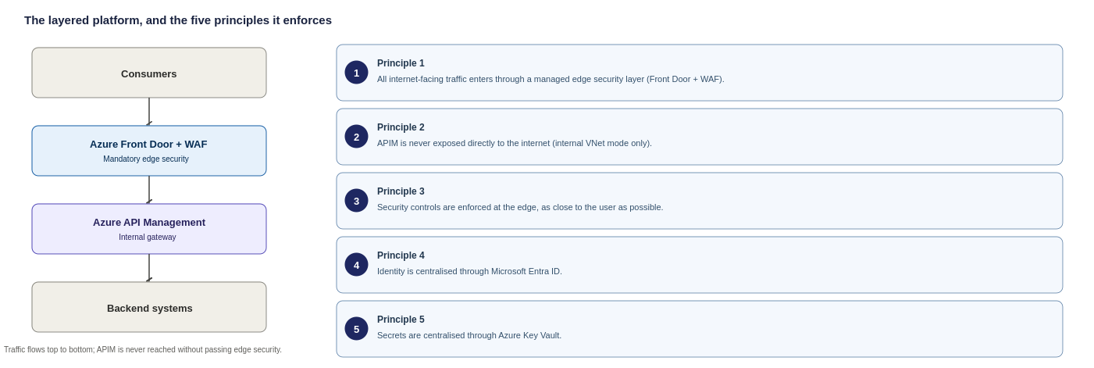
Figure 1: The mandatory layer order every request follows

These principles produce one consistent routing model. The table below shows how each traffic type is routed as a result: every external path goes through the edge, internal traffic reaches the internal gateway directly, and outbound calls leave through the controlled egress path.
Traffic type | Route
External consumer to organisational API | External Consumer → Edge Service (Azure Front Door) → APIM Gateway (internal) → Backend Service
Internal application to organisational API | Internal Application → APIM Internal Gateway → Backend Service
Third-party webhook inbound | Third Party → Edge Service (Azure Front Door) → APIM Gateway (internal) → Function or Backend Service
Outbound call to third-party API | Function or Application Service → APIM Outbound Gateway → Third-Party API

APIM is the standard ingress point for all enterprise-managed APIs. Where a valid business or technical reason exists, exceptions may be approved and documented through the architecture governance process. This ensures the API boundary remains clear, secure, and governed. The edge service in this table is Azure Front Door: every external and partner path in this design passes through it before reaching APIM, and the reasoning behind that choice is set out in full in section 2.

Solution Summary
One control plane. One security model. Every API, internal, external, and partner, governed consistently on Azure API Management.
The diagram below shows how the Organization’s API estate matures over time, not to describe a single point-in-time architecture. Read it top to bottom as four stages, each building on the one before, the key takeaway is that every stage keeps the same governance model (a central platform team owning the shared platform and standards while domain teams own their own APIs, with all changes flowing through the APIOps pipeline and design gates), so the Organization is never rebuilding, only extending.
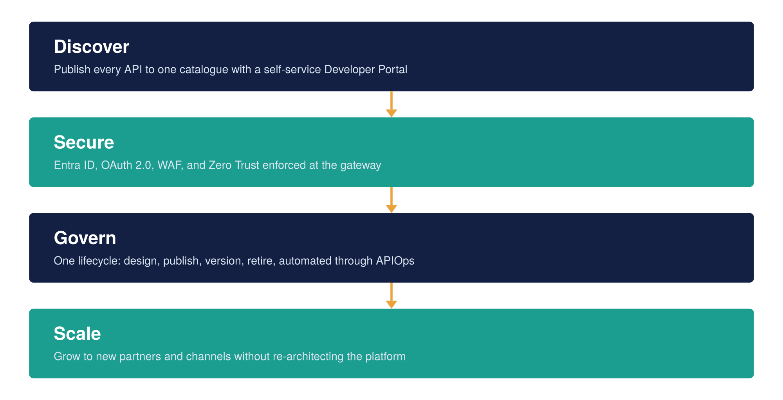
Figure 2: The APIM vision, four stages from discovery to scale

APIM Service Architecture

This section shows how a single API request travels from an external consumer through each security and routing layer to the backend that answers it and where the shared services (identity and secrets) sit relative to that path. The goal is one governed flow that every API follows, so security is applied consistently rather than rebuilt per integration.
Ingress Request Flow
This diagram shows the inbound (ingress) request flow, how a request travels from a consumer through the edge and APIM to the backend. Outbound (egress) traffic is shown separately in Figure 4.
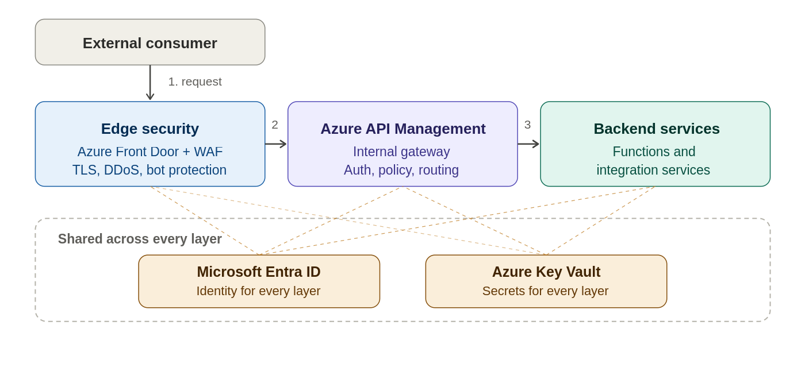
Figure 3: High-level Azure APIM architecture for the Organization
Egress Request Flow
This diagram shows the outbound (egress) traffic flow, how APIM and backends reach external third-party APIs through the Palo Alto firewall.

Key takeaway: external calls don't leave directly from individual functions or microservices — they route through APIM and the central firewall egress, so every external call is inspected, authenticated, and controlled in one place (the egress-gateway pattern).

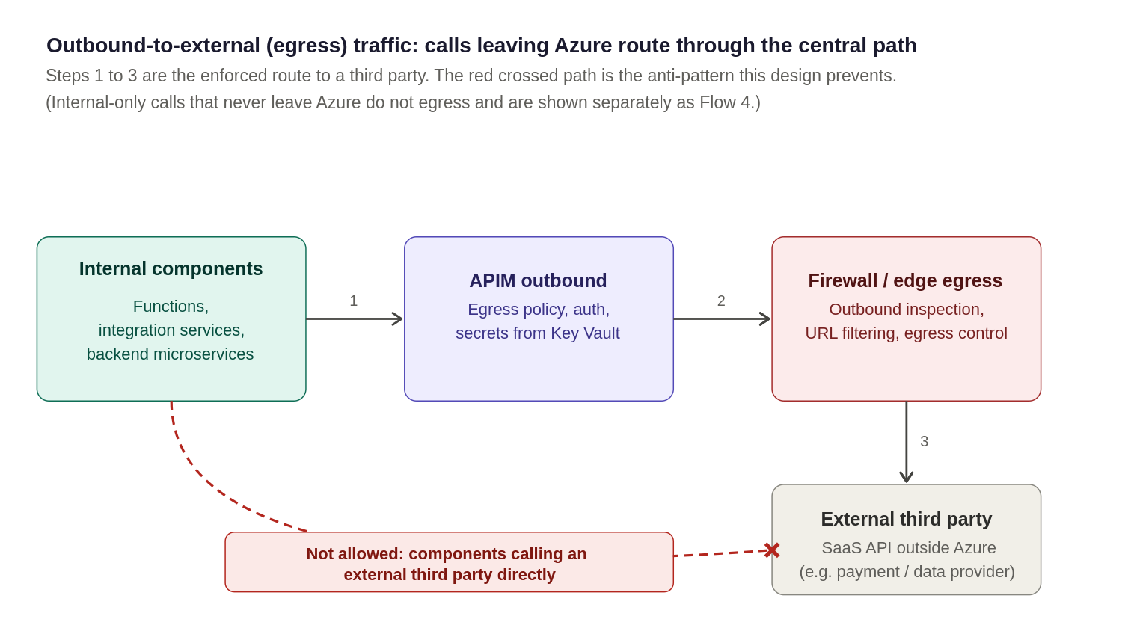
Figure 4: Outbound-to-external (egress) traffic, calls leaving Azure to a third party route through the central egress path
Note: this covers outbound-to-external only. Internal calls (APIM to a private backend) never hit the internet and are shown separately as Flow 4 in the appendix
The design workflow above follows three Microsoft-published reference architectures made for this exact scenario , so it's a proven, supported approach.
- Basic Enterprise Integration on Azure: Microsoft's reference architecture for exposing and managing integration services through API Management.
- Front Door in front of API Management: Microsoft's documented pattern for placing Azure Front Door ahead of API Management for global routing, WAF protection and Private Link connectivity into a VNet-injected gateway, the exact combination this design uses.
- API Management Landing Zone Accelerator: Guidance from the Cloud Adoption Framework for deploying API Management at enterprise scale, covering networking, security, governance, and identity.

How APIM relates to Azure’s other ingress and load-balancing services
APIM is one of several Azure services that sit between a client and a backend, and they are often confused because they occupy similar positions in the request path. They are not substitutes: each operates at a different layer and does a different job. The table below places APIM among them, so it is clear why this design layers Front Door in front of APIM rather than using either service alone.
Service | Layer | Its distinct job | Role in this design
Azure Front Door | L7, global edge | Anycast routing, edge WAF, DDoS absorption and TLS termination closest to the user | The chosen edge service in front of APIM
Application Gateway | L7, regional | Regional WAF, URL routing and SSL offload inside a VNet | Considered and not chosen (see section 2)
Azure API Management | API gateway | API versioning, per-subscription throttling, JWT/subscription-key auth, transformation and the developer portal | The core of this platform
Azure Load Balancer | L4, regional | Raw TCP/UDP connection distribution for non-HTTP workloads | Not used, the APIs here are HTTPS, handled at L7
Traffic Manager | DNS-based | Influences DNS resolution only; does not terminate or inspect traffic | Superseded by Front Door for HTTPS (see section 6)
Two points explain why APIM cannot stand at the edge alone, and why the layers are additive rather than redundant:
APIM is not a load balancer. It manages the API contract, who may call which operation, on what terms, with what transformation, but it does not distribute traffic across regions for high availability. That resilience comes from Front Door (global) and the multi-region deployment, not from APIM.
APIM is not a WAF. Its policies enforce throttling, authentication and transformation, but they are not an OWASP web application firewall. Injection attacks, protocol exploits and volumetric floods are blocked by the Front Door WAF in front, not by APIM. Placing APIM at the edge without a WAF ahead of it would leave those attack classes unfiltered.
Each layer therefore filters a different class of concern before the request moves inward, which is what makes the Front Door plus internal-mode APIM combination defence in depth rather than duplication.

Network and Connectivity Design
The design decisions this section implements, Azure Front Door + WAF as the edge service and APIM in internal (VNet) mode, are made and justified in section 2 (Design Decision). This section does not re-open those choices, it shows the concrete network topology that delivers them, so a reader can go straight to how the chosen design is actually built. It covers the ingress topology, how APIM integrates with the existing firewall, multi-region layout, subnet sizing and the required network components.
Ingress topology
The chosen ingress topology is Azure Front Door + WAF in front of an internal-mode APIM (option A in section 2). The diagram below shows it end to end, alongside the two alternatives that were considered and rejected, so the chosen path can be seen in context. In every case APIM runs in internal mode and is never exposed directly to the internet; what differs is only what sits in front of it.
The three ingress options are shown separately below. Option A is the chosen edge service; the decision and full comparison are in section 2 (Edge Service Selection Decision).
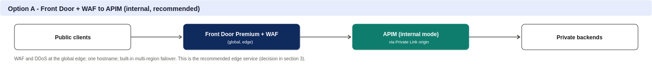

Figure 5: Option A, Front Door + WAF (chosen, see section 2)
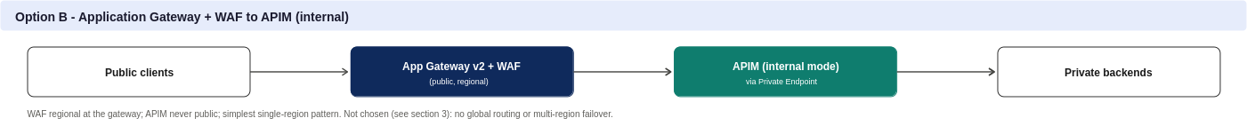
Figure 6: Option B, Application Gateway + WAF (not chosen)
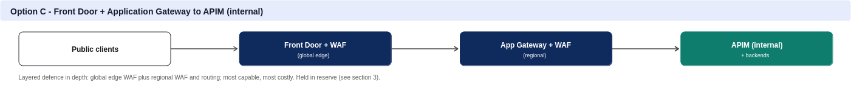
Figure 7: Option C, Front Door + Application Gateway (held in reserve)
This topology runs on classic Premium in multi-region mode, the tier chosen in section 2. The concrete instance settings that implement it are below.
Instance configuration
The table below sets out the key configuration attributes of the APIM instance itself, the tier, region layout, network mode, custom domains, TLS and identity. These are the proposed target values. Custom domain names are illustrative placeholders, and the VNet mode and region choices are proposals to confirm against the Organization’s landing zone and naming standards, not settled facts.
Attribute | Proposed value | Status
Tier | Classic Premium (production) | Proposed
Region | UK South, primary; UK West, secondary | To confirm (data residency)
VNet mode | Internal (VNet injection) only | To confirm against landing zone
Custom domain | api.organization.com (external), api-internal.organization.com (internal) | Illustrative placeholder
TLS | 1.2 minimum | Proposed standard
Managed identity | System-assigned | Proposed

Why the gateway is internal-only
APIM runs in internal (VNet) mode only, with no external gateway, in line with the deployment-mode decision in section 2. External mode, exposing a public APIM endpoint even with IP restriction, was considered and rejected: it leaves a public surface an attacker can reach directly, whereas internal mode removes that class of exposure entirely. All external and partner traffic still reaches APIM, but only after passing through Azure Front Door over Private Link, so there is a single, inspected way in and no internal system is ever punched out to the public internet. This keeps the design consistent with the single-ingress and zero-trust principles without needing a second, public-facing gateway.
 | Internal mode (chosen) | External mode (rejected)
Public endpoint | None, APIM sits inside the VNet | Yes, APIM is exposed on the internet
How consumers reach it | Only through Front Door over Private Link | Directly, even if IP-restricted
Attack surface | No public surface to reach APIM directly | A public surface an attacker can target
Fit with single-ingress / zero-trust | Consistent, one inspected way in | Weakens it, adds a second public gateway

Multi-region topology
Why this matters: a multi-region deployment means the Organization keeps serving API traffic even if an entire Azure region, UK South, say, goes offline. It is not the same thing as the zone redundancy already built into a single-region deployment, and the two protect against different failures. Front Door is what makes multi-region possible here: it holds one global hostname and automatically stops sending traffic to a region that fails its health checks, so failover needs no manual DNS change or partner reconfiguration. The trade-off is cost: a second region means a second set of APIM units and backend capacity running live, not idle, so multi-region roughly doubles the compute bill for the platform. The way to control that cost is to scope it: only the APIs that genuinely need cross-region resilience have to run active-active; lower-priority internal APIs can stay single-region with zone redundancy, which is far cheaper. That scoping decision belongs with the business, not with this design.
 | Availability zones (single region) | Multi-region
Protects against | Loss of one datacentre | Loss of an entire Azure region
Typical cost impact | Small: spreads existing units across zones | Large: roughly doubles running capacity
Failover | Automatic, inside the region | Automatic via Front Door, across regions
Needed for | Every production API, low cost to include | Only APIs where a full regional outage is unacceptable
This table is the network-topology view of the zones-versus-regions choice, shown here because it shapes how APIM is deployed across regions. The full HA/DR options, the cost-tiered recommendation and the resilience decision are set out in section 14; this is not repeated there.
the Organization’s two are not competing options: zone redundancy is the cheap, default protection every production API should have, and multi-region is the expensive, targeted protection added on top only where the business case justifies it.
For APIs that do need active-active multi-region, the topology is as follows. Both regions run active behind the same Front Door entry point, each with its own APIM gateway and a geo-redundant backend replica. Front Door decides which region serves a given request and moves traffic away from a region automatically if its health probes fail.
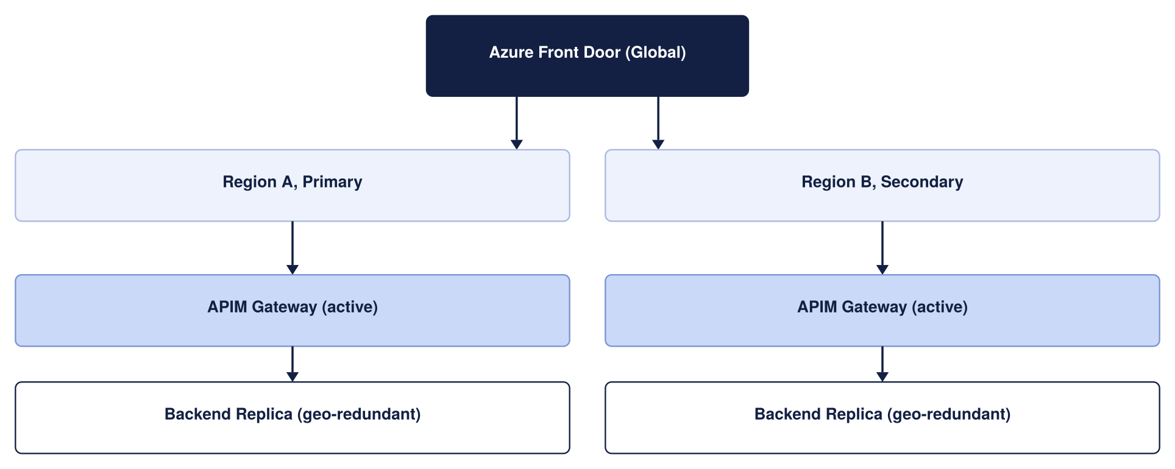
Figure 8: Multi-region APIM architecture
The target design places backends (integration services and Functions, Service Bus) in private subnets reachable only from APIM, using Private Endpoints and network security groups. Front Door or Application Gateway terminates public traffic and forwards only validated requests through to the APIM internal gateway, which is reachable purely from within the VNet, with no public exposure at all. This describes the intended target state rather than a confirmed picture of the Organization’s current network: the actual VNet layout, private DNS zone ownership, and any forced-tunnelling or NVA egress rules must be validated against the Organization’s landing zone, because they can materially change how APIM reaches each backend. This is the single most important item to verify before detailed design (see section 16).
The diagram below sets out exactly what internal traffic passes through, matching the pattern proven on our reference deployment. The external path (public clients through Front Door and WAF to the internal-mode APIM) is the recommended Option A shown in the ingress-topology diagram earlier in this section, and is not repeated here.
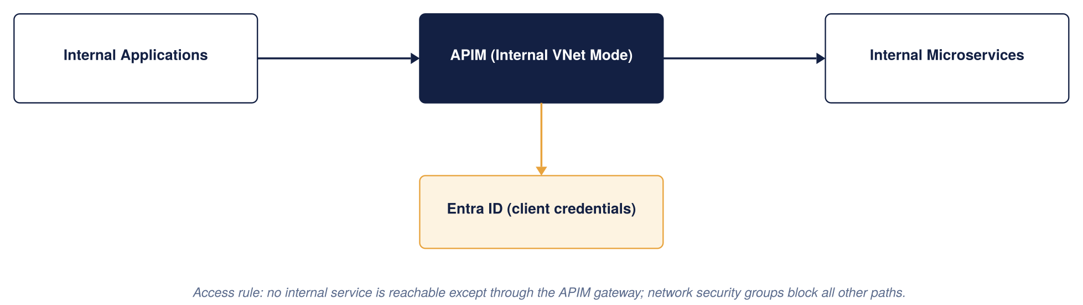
Figure 9: Internal API access model
How the Edge Service and APIM secured
The two decisions above set what the platform is: Front Door at the edge, classic Premium with VNet injection. Everything from here is how that gets implemented safely inside the Organization’s existing network, principally its Palo Alto firewall, and inspected. A leadership reader can treat the decisions as the takeaway; the material below is for the team that builds and reviews the network.
Integrating APIM with the Organization’s Palo Alto firewall
The Organization uses Palo Alto as its egress firewall. In this design it inspects and controls outbound traffic to external third parties only: inbound traffic enters through Front Door over Private Link and does not traverse the firewall, and internal-only calls stay on the private network. The egress flow is worked through step by step in the appendix "Network traffic flows in detail".
Implementing the egress firewall: NVA or Cloud NGFW
The egress firewall can be delivered two ways. Both are Palo Alto and both do the same job here (inspecting outbound third-party traffic); they differ in how the firewall is run and operated.
Option | What it is | Trade-offs
Traditional NVA | A Palo Alto firewall appliance the Organization runs itself in a hub VNet, behind an internal load balancer, with outbound routed to it by user-defined routes | Full control and reuses an existing hub firewall if one is already in place; but the Organization builds, patches, scales and operates the appliance
Cloud NGFW (Azure-native) | Palo Alto’s firewall as a managed Azure service (the PaloAltoNetworks.Cloudngfw resource), provisioned from the Marketplace, billed through Azure and managed from the Azure portal or Panorama | Microsoft-and-Palo-Alto co-developed and managed, scales automatically and integrates natively with Azure routing, removing the build-and-patch burden; newer, and introduces a managed SaaS dependency
Recommendation: for a new egress control, Cloud NGFW is the cleaner Azure-native choice, as it removes the operational overhead of running a firewall appliance. Where the Organization already operates a Palo Alto NVA in its hub, reusing it is equally valid. Either way the topology below is the same: outbound third-party traffic is routed to the Palo Alto for inspection; the choice is confirmed with the Organization’s network team. Only the outbound path uses the firewall, so this decision does not affect the ingress design.
Topology and the guiding principle
The Palo Alto egress firewall sits in the hub (as a self-run NVA behind an internal load balancer, or as a Cloud NGFW resource). APIM sits in a delegated subnet in a spoke VNet, peered to the hub, and runs in internal mode so its data-plane gateway has a private virtual IP and no public data-plane address. A route table (UDR) on the APIM subnet sends outbound traffic destined for external third parties to the Palo Alto for inspection. The guiding principle is that outbound traffic leaving Azure to a third party is inspected by the Palo Alto, while inbound traffic (through Front Door) and internal-only traffic stay off the firewall. One deliberate, documented exception still applies to any outbound routing through a firewall: Azure's own control-plane traffic must bypass it for APIM to function at all.
That exception is the single most important design point when combining APIM with any NVA, so it is worth stating plainly before the flows: if Azure's management traffic to APIM is force-tunnelled through the firewall, the return path is asymmetric, the stateful firewall drops it, and APIM loses connectivity to the Azure control plane, breaking scaling, updates, and monitoring. The fix is a specific route, covered under Required network artefacts below and detailed in the flows appendix.
The inbound and outbound paths, and where Palo Alto sits
One point must be settled before the individual flows make sense, because it determines where the firewall sits. In this design the firewall is an outbound (egress) control only: inbound traffic never passes through Palo Alto. The two paths are:
Inbound (ingress): External user → the edge (Azure Front Door + WAF) → APIM over Private Link → backend. Public traffic reaches Front Door at the Microsoft edge, where the WAF, TLS termination and DDoS protection are applied, and Front Door forwards it to APIM over a Private Link inbound private endpoint, travelling the Azure backbone directly into the APIM spoke. Inbound inspection is performed by Front Door’s WAF; the Palo Alto is not in the inbound path at all. The origin is locked down so APIM accepts traffic only from the Organization’s Front Door instance (Private Link approval, an NSG that denies the internet, and verification of the X-Azure-FDID header).
Outbound (egress): APIM or a backend → Palo Alto → external third-party API. All outbound calls that leave Azure to a third party are forced through the Palo Alto for egress inspection and URL filtering, as confirmed by the Organization. Internal-only calls (APIM to a private backend, or APIM to an internal API) stay on the private network and do not traverse the firewall.
So the firewall does one job here: controlling and inspecting outbound traffic to external third parties. It is deliberately kept off the inbound path, which keeps the ingress design simple (one inspected way in, through Front Door) and avoids the cost and complexity of double-inspecting inbound traffic.
A compatibility note to confirm at build time: routing Front Door to an internal-mode classic Premium instance over an inbound private endpoint depends on the specific tier and network-mode support in force at build time, which Microsoft has been actively extending (inbound private endpoints, and workspaces on the built-in gateway with Private Link, have both moved forward recently). The Organization should validate the exact Front Door → Private Link → internal APIM path against the current Azure capability for the chosen tier before locking the network design. If it is not available for the chosen tier at build time, Application Gateway (the fallback edge in section 2) provides the WAF instead; either way the firewall stays on the egress path only.
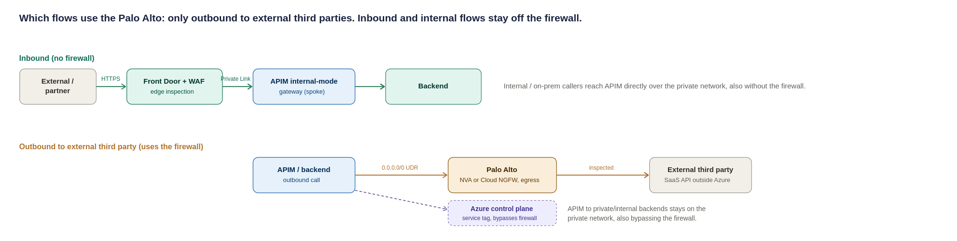
Figure 10: Which flows use the Palo Alto, only outbound traffic to external third parties; inbound (Front Door/Private Link) and internal flows stay off the firewall
Summary of which flows use the firewall:
Traffic flow | Through Palo Alto? | How it is secured
External inbound (via Front Door) | No, bypasses the firewall by design | Front Door WAF at the edge; origin locked to Front Door (Private Link + NSG + X-Azure-FDID)
Internal inbound | No, stays on the private network | Reaches the APIM internal gateway directly over peering/ExpressRoute; authenticated and policy-checked at APIM
Outbound to external third party | Yes | Forced-tunnel UDR to the Palo Alto; egress inspection and URL-filtering policy
APIM to private / internal backend | No, stays private | Private Endpoint + NSG; stays on the Azure backbone, does not traverse the firewall
Azure control plane | No, must bypass | ApiManagement service tag UDR next-hop Internet (mandatory, section below)
The table above is the complete answer for most readers: it says which flows touch the firewall and how each is secured. The step-by-step configuration of all five flows, the exact user-defined routes and NSG entries a network engineer needs to build them, is set out in the appendix "Network traffic flows in detail" so it does not interrupt the design narrative here. The one flow that must not be missed, the mandatory control-plane bypass, is also called out separately under Required network artefacts below because getting it wrong silently breaks the platform.
Required routing and firewall summary
Pulling the flows together, the concrete configuration is:
Path | Where enforced | Rule
External inbound | Front Door + WAF (edge) | WAF/TLS/DDoS at the edge; Private Link origin to APIM; NSG denies direct internet; no firewall on inbound
Internal inbound | APIM (private network) | Reaches APIM internal gateway directly over peering/ExpressRoute; authenticated and policy-checked at APIM; no firewall
Outbound to external third party | APIM subnet UDR + Palo Alto | 0.0.0.0/0 (or third-party ranges) next hop = Palo Alto; egress inspection and URL filtering on the firewall
APIM to private / internal backend | NSG + Private Endpoint | Private path, stays on the Azure backbone; does not traverse the firewall
Control plane (mandatory) | APIM subnet UDR | ApiManagement service tag next hop = Internet (bypasses any firewall)
Platform dependencies | APIM subnet UDR / NSG | Allow AzureMonitor, Storage, Key Vault, etc. by service tag

Two failure modes to design out explicitly: asymmetric routing on the egress path, prevented by the control-plane and dependency bypass routes above; and route-table sprawl, avoided by using service tags rather than long lists of individual IP routes. With those in place, the Organization uses Palo Alto as the egress-control point for APIM's outbound traffic to external third parties, while inbound and internal traffic stay off the firewall and APIM stays healthy on Azure's control plane.
Subnet sizing (to confirm against the landing zone)
Sizing the APIM delegated subnet and its neighbours correctly the first time avoids a disruptive resize later, since an Azure subnet cannot easily be shrunk or re-carved once resources are deployed into it. The figures below are starting points for detailed design, not a final IP plan; the actual VNet address space must come from the Organization’s IPAM and hub-spoke allocation.
Subnet | Minimum size | Why
APIM delegated subnet (classic Premium, VNet injection) | /27 (32 addresses) per region as an absolute floor; /26 recommended | Classic Premium reserves a block of addresses per scale unit and for platform use; a /27 leaves little headroom for adding units, so /26 is the safer planning default
Application Gateway subnet (if Option B/C is used) | /26 recommended, /27 minimum | Autoscaling instances each consume an address; undersizing blocks scale-out under load
Palo Alto internal load balancer / hub subnet | Per the Organization’s existing hub design | Owned by the network team; not part of this HLD’s sizing, referenced here for completeness
Private Endpoint subnet(s) for backends | /27 per subnet is usually sufficient | One address per Private Endpoint; size to the number of backend services expected, with headroom
This is flagged as an open item because it depends on facts this HLD does not have: the actual hub-spoke address plan, whether the Organization reserves address space per environment or per region, and how many scale units Production is expected to reach. It should be resolved alongside the landing-zone validation already called out as the top item in the assumptions register (section 16, A.02 and A.03).
Required network artefacts and the asymmetric-routing gate
In plain terms: Azure needs to manage APIM over the internet, but the firewall wants to inspect everything, and those two requirements clash unless one specific route is added to let Azure's management traffic skip the firewall. Miss that one route and APIM quietly stops responding to scaling, updates and health checks, with no obvious error pointing at the cause. Section 7 sets the topology; this checklist is what a network engineer needs to produce the detailed design without re-deriving it. It also names the one failure mode that must be handled explicitly, because getting it wrong silently breaks the platform.
The non-negotiable gate: the APIM control-plane bypass. When APIM is injected into a VNet and outbound traffic is force-tunnelled through the Palo Alto, the return path for Azure’s own management traffic to the APIM management endpoint (port 3443) no longer maps back symmetrically. This asymmetric routing drops the management connection and, left unaddressed, breaks configuration, scaling and health of the instance. The documented fix is mandatory: a user-defined route for the ApiManagement service tag with next hop set to Internet, which steers that control-plane return traffic straight back to Azure rather than through the firewall. Microsoft is explicit that allowing this management traffic to bypass the NVA is not a meaningful security risk. This UDR is a required build artefact, not an optimisation, and should be treated as a design gate that TDA checks for.
Network artefact | Requirement | Owner
UDR: control-plane bypass | Route for ApiManagement service tag, next hop = Internet (MANDATORY: prevents the asymmetric-routing failure above) | Network
UDR: egress | Route for outbound-to-external traffic → Palo Alto for egress inspection and URL filtering (third-party destinations) | Network
UDR: east-west (optional) | /32 route to the firewall only if policy requires PE traffic to be inspected; otherwise Private Endpoint + NSG is the default and east-west does not traverse the NVA | Network + Security
NSG: management | Allow inbound TCP 3443 from the ApiManagement service tag only (use the service tag, not hard-coded IPs, which change) | Network
NSG: gateway | Allow 443 from the Front Door Private Link path and internal ranges only; deny the Internet service tag | Network
NSG: load balancer | Allow inbound from the AzureLoadBalancer service tag | Network
DNAT (not used) | Not used in this design: inbound arrives via Front Door Private Link, not a firewall public VIP | Network
Private DNS | Do NOT create a Private DNS zone for azure-api.net. Create explicit A records mapping each APIM endpoint FQDN to the private VIP, resolvable from all VNets and on-prem networks that need access | Platform + Network
Backend DNS resolution | Azure Private DNS Resolver with forwarding rulesets for APIM-to-on-prem backend name resolution | Network
ExpressRoute / VPN return-path symmetry | Ensure symmetric routing for on-prem consumers reaching the internal VIP: UDRs and firewall rules must be consistent on both the Azure and on-prem sides so return traffic follows the forward path | Network
IP plan (placeholder for the network team). Subnet sizing must be validated against the Organization’s IPAM and expected scale. As a planning rule, one Premium unit in internal mode consumes about three subnet IPs (one private VIP plus one per gateway VM), and each additional scale unit consumes more, so the subnet must leave headroom for the maximum unit count the region will ever run; backends should allow-list the whole APIM subnet rather than individual instance IPs, which change on scale-out. A dedicated /26 per region is the recommended default, to be confirmed below.
Subnet (indicative name) | Purpose | Suggested size | Address range
snet-apim-prod-uksouth | APIM injection (internal mode), UK South | /26 (default) | To confirm vs IPAM
snet-apim-prod-ukwest | APIM injection (internal mode), UK West | /26 (default) | To confirm vs IPAM
snet-pe-backends-* | Private Endpoints for integration services, Functions and Service Bus | /26 | To confirm vs IPAM
snet-frontdoor-pl-* | Front Door Private Link | /27 | To confirm vs IPAM
hub firewall subnets | Palo Alto NVA (trust / untrust / mgmt) | Per vendor guidance | Owned by Network

Network traffic flows in detail
This appendix holds the step-by-step configuration of the five traffic flows summarised in section 6 (Network and Connectivity Design). It is written for the network engineer building the platform and is deliberately kept out of the main design narrative. Each flow states what it is, how it is routed through or around the Palo Alto firewall, and the specific routing and firewall rules it needs. The summary table in section 6 is the quick reference; this is the build detail behind it.
Flow 1: external inbound (external to internal)
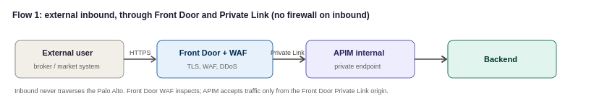
An external consumer, a broker or Lloyd’s market system, reaches the Organization over the internet. Traffic lands at Azure Front Door, where the WAF, TLS termination and DDoS protection are applied, and Front Door forwards the validated request to APIM over a Private Link inbound private endpoint. Because APIM is internal-mode it has no public endpoint; the only way in is through Front Door over Private Link. Inbound traffic does not traverse the Palo Alto, which is an egress control only.
- Front Door: WAF (OWASP + bot rules), TLS termination and DDoS protection at the edge; Private Link origin to the APIM inbound private endpoint.
- APIM subnet NSG: allow inbound only from the Front Door Private Link path; deny direct internet inbound. Origin locked to the Organization’s Front Door instance (Private Link approval + X-Azure-FDID header verification).
- No firewall on this path: the return path is symmetric because Front Door and APIM communicate over Private Link on the Azure backbone, with no NVA in the middle.
Flow 2: internal inbound (internal to APIM)
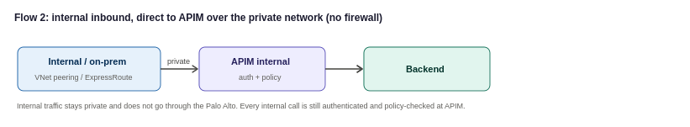
An internal Organization system, or an on-premises system reaching Azure over ExpressRoute or VPN, calls an internal API. The call reaches the APIM internal gateway directly over the private network (VNet peering, or ExpressRoute/VPN for on-premises), and APIM applies authentication and policy before forwarding to the backend. Internal traffic stays on the private network and does not traverse the Palo Alto, which handles egress to external third parties only. Internal consumers still never bypass the gateway: every internal call is authenticated and policy-checked at APIM, in line with the zero-trust principle in the security section. For on-premises sources, route propagation must be enabled so the return path stays symmetric.
Flow 3: outbound (internal to external)
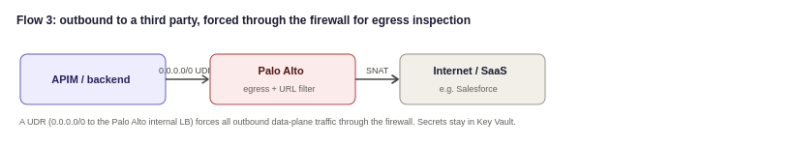
When APIM or a backend needs to call out, to a public SaaS provider such as Salesforce, or to any internet endpoint, that traffic must be inspected on the way out. A UDR on the APIM subnet with destination 0.0.0.0/0 and next hop set to the Palo Alto's internal load-balancer IP forces all outbound data-plane traffic through the firewall, where egress policy and threat prevention apply. This is the flow that gives the Organization the outbound inspection and audit it runs the Palo Alto for in the first place.
- APIM subnet UDR: 0.0.0.0/0 with next hop = Palo Alto internal LB IP (forced tunnelling).
- Palo Alto: outbound security and URL-filtering policy for the destinations APIM is permitted to reach; SNAT as required.
- Credentials for SaaS calls stay in Key Vault-backed named values; the firewall controls the path, not the secret.
Flow 4: APIM to private backends
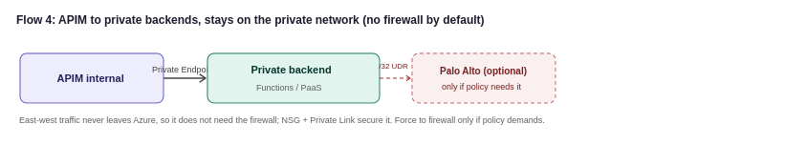
Calls from APIM to backends that live inside the Organization’s own network, integration services and Functions, or PaaS reached over Private Endpoint, stay on the private network. These do not need to traverse the Palo Alto to reach the internet, since they never leave Azure's backbone. If the Organization’s security standard requires even east-west private traffic to be inspected, Private Endpoint traffic can be forced to the firewall with a /32 UDR per endpoint, at the cost of route-table management; most designs inspect north-south (internet-facing) traffic at the firewall and rely on NSGs and Private Link for east-west, which is the approach recommended here unless the Organization’s policy says otherwise.
Flow 5: the control-plane exception (mandatory)
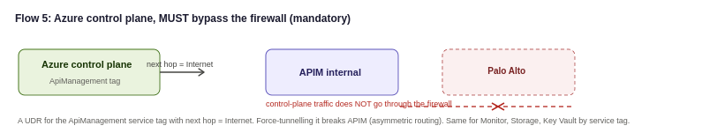
Azure manages APIM over a control-plane channel using the ApiManagement service tag. This traffic uses Azure's own public IP ranges, so if it is force-tunnelled through the Palo Alto the responses do not map symmetrically back and the stateful firewall drops them. The required, Microsoft-documented configuration is a UDR on the APIM subnet for the ApiManagement service tag with next hop set to Internet, so control-plane traffic bypasses the firewall. Microsoft is explicit that allowing this management traffic to bypass the NVA is not a significant security risk, because it is Azure's own management channel, not the Organization’s data. The same bypass applies to the platform dependencies APIM needs (Azure Monitor, Storage, Key Vault, and similar), which should be allowed by service tag rather than by IP.

Traffic Management and Edge Security
The edge and global-routing design, including the choice of Azure Front Door over Traffic Manager and the ingress topology, is set out within the network design in section 6 (see the ingress options and the Front Door versus Traffic Manager comparison). In summary: Azure Front Door Premium with WAF provides the global entry point, edge security and automatic multi-region failover for external and partner traffic; the Palo Alto firewall provides network inspection; and APIM runs in internal mode behind them.

Authentication and Security Design
Security is the highest priority in this design. It is checked at every hop, never assumed at the backend, and never granted just because a call came from inside the Organization’s network. Concretely, this means a request is never trusted just because it made it past the previous layer: identity is checked, then the network path is checked, then the gateway's own policies are checked, and so on, so that no single mistake in one layer exposes a backend. The diagram below is a map of those checks, read top to bottom: a request passes every layer in turn before any backend is reached, and each layer is shown next to the specific threat it defends against. The layers are ordered deliberately, not just listed, and a request that fails any one of them never proceeds.
Security architecture: defence in depth at a glance
Before the individual controls, the diagram below sets out the security architecture as a whole: a mandatory transport layer, then the enforcement checks each owning a distinct job, that an inbound request passes before any backend is reached. This is the standard Azure defence-in-depth pattern for a private-mode APIM behind an edge WAF, and it is the frame the rest of this section fills in. No single layer is a substitute for another; the security of the platform is the composition of them all.
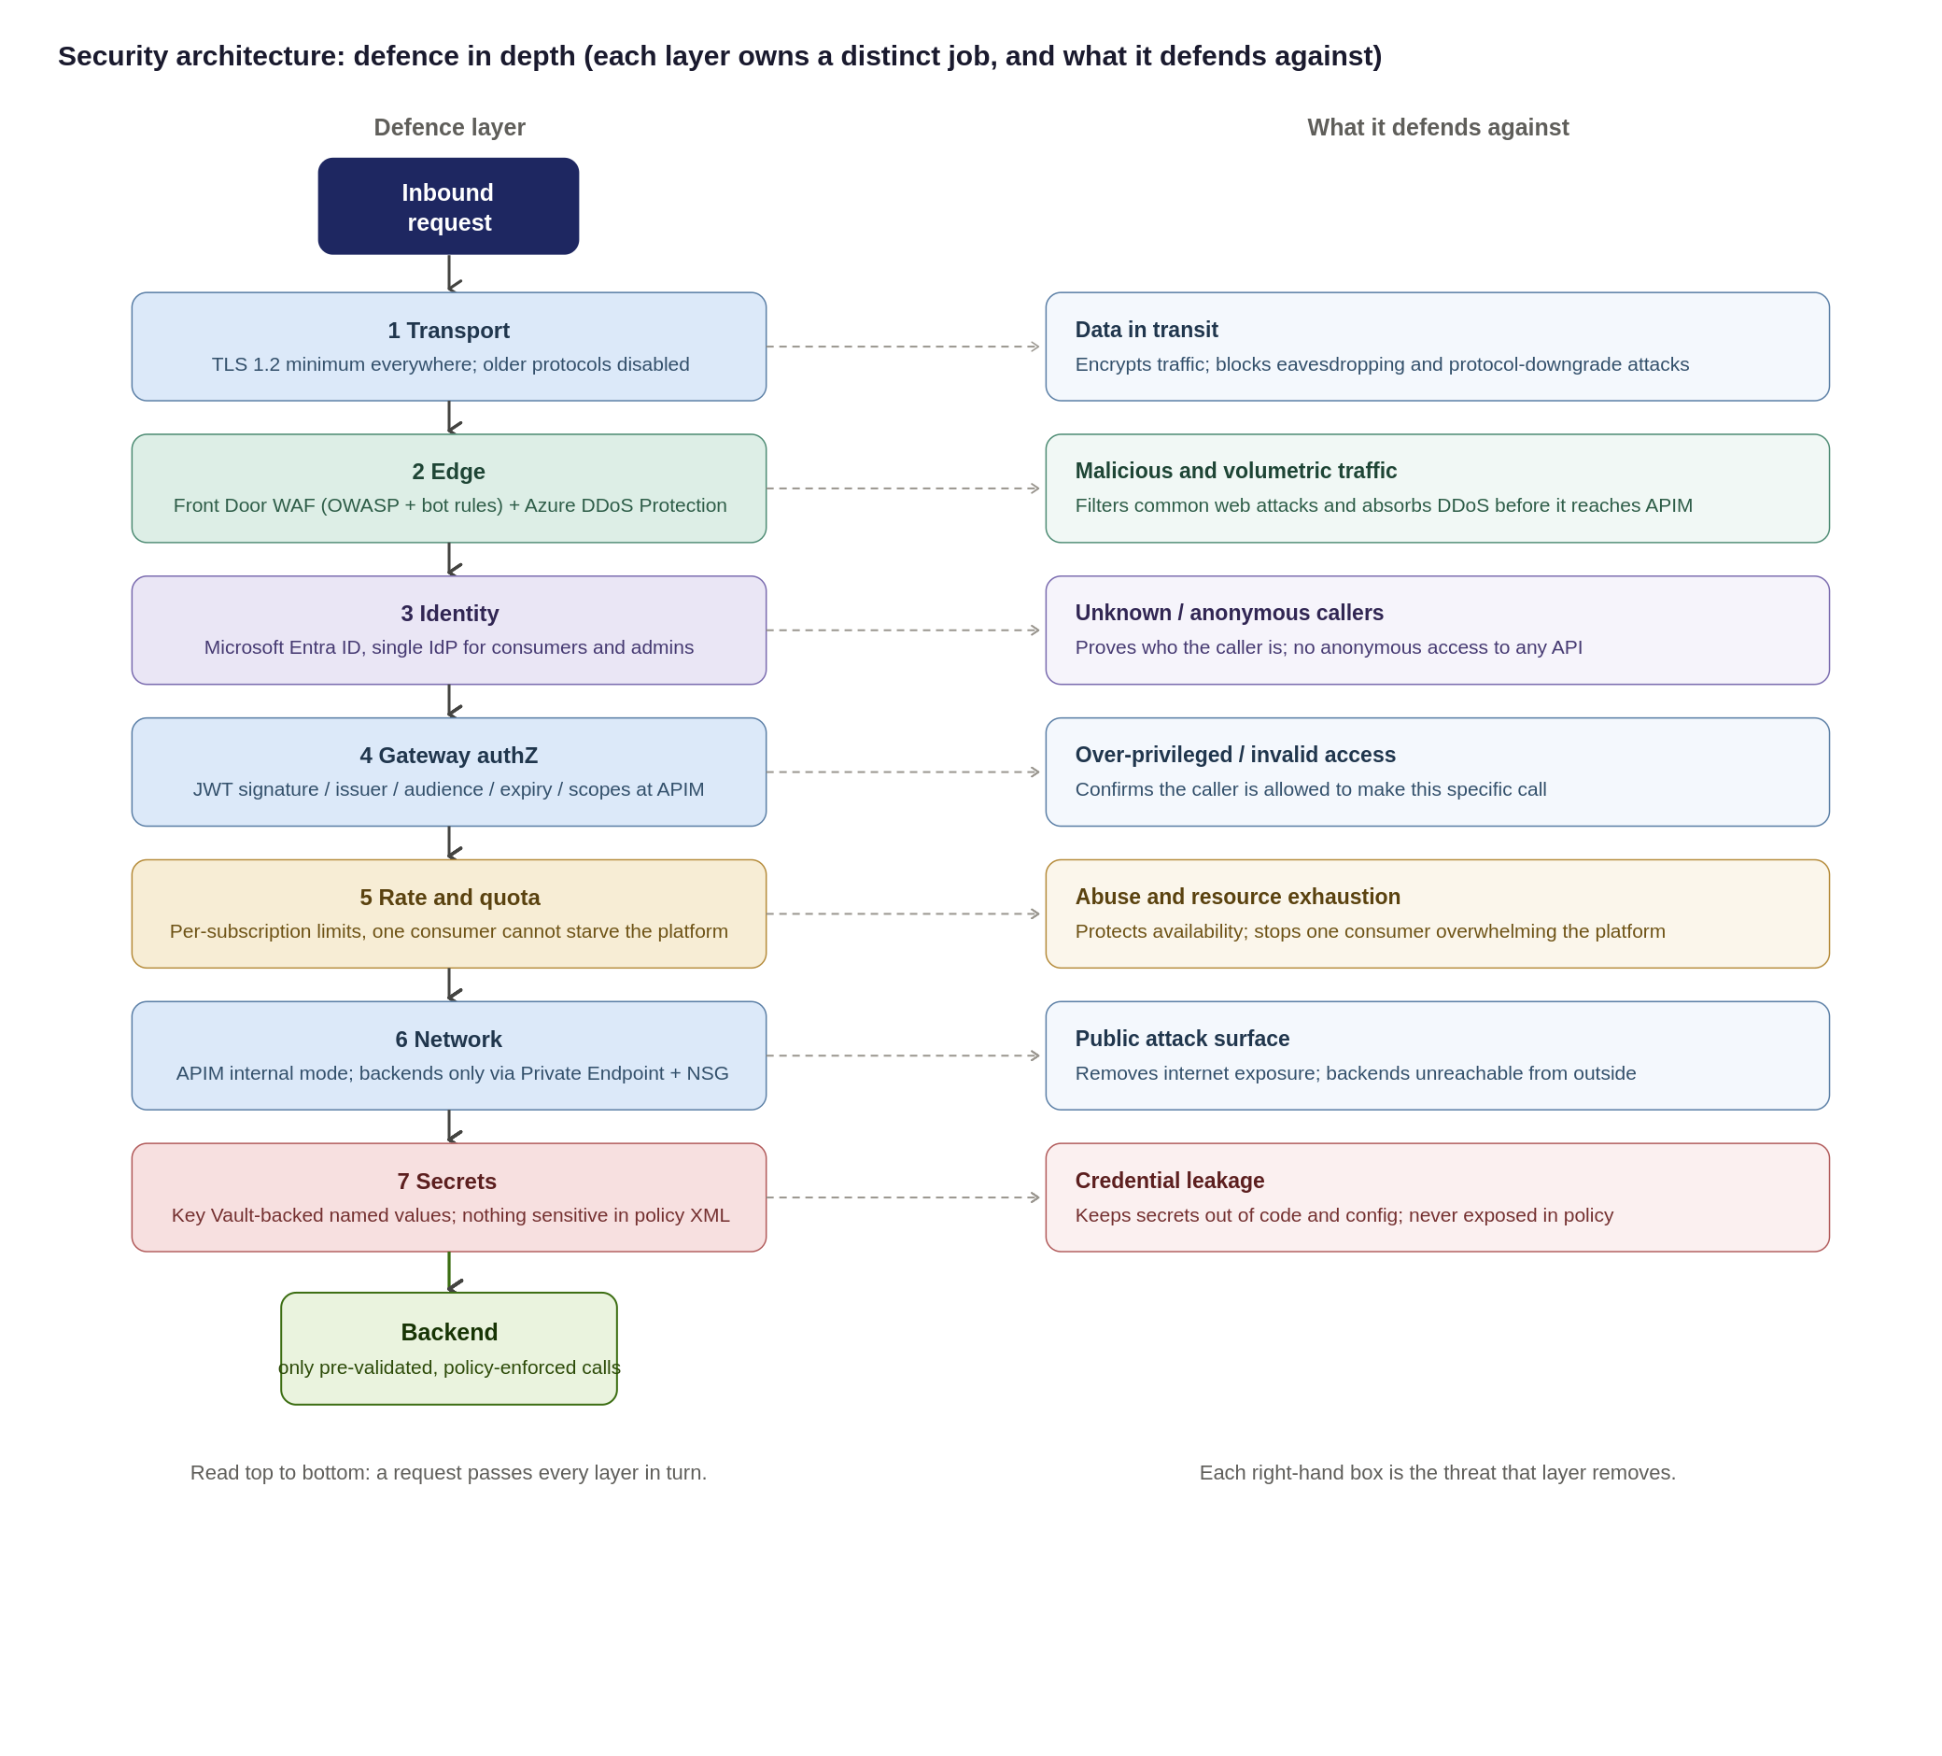
Security design principles and residual risk
The controls in this section all serve a small set of principles, stated here so a reviewer can see the intent behind them: verify every hop (nothing is trusted because it came from inside the network), defence in depth (no single control is load-bearing), least privilege (consumers, pipelines and admins get the minimum access needed); deny by default and secure by default (APIs are private and authenticated unless a decision is made otherwise), one identity provider (Entra ID for consumers and administrators alike), everything as code (security configuration is reviewed and version-controlled, never hand-set in Production), and secrets never in code (Key Vault-backed named values only).
No design removes all risk. The residual risks below are the ones that remain after the controls, with the compensating measure and the owner who carries them: this is deliberately explicit so nothing is presented as fully solved when it is not.
Residual risk | Why it remains | Compensating control | Owner
Backend object-level authorization (BOLA) cannot be enforced at the gateway | APIM validates identity and passes claims, but only the backend knows its own object model | Mandatory backend-authorization standard, code review and contract tests per API | Domain teams
Non-OAuth exception consumers weaken the single-IdP model | Some partners cannot support OAuth 2.0 | mTLS or IP allow-list plus short-lived rotating secret; time-boxed, reviewed exception (below) | Security
Compliance mapping not yet independently verified | The Organization control catalogue not cross-checked against this design | Compliance sign-off of the control-to-evidence matrix before go-live | Compliance
Capacity behaviour under real peak load unproven | The Organization peak requests-per-second not yet provided | Load test before go-live; capacity-metric autoscale with headroom | Platform
Single ingress concentrates blast radius | A shared platform is a bigger target than scattered endpoints | Rate limits, workspace isolation, multi-region, WAF/DDoS, break-glass runbook | Platform + Security
Threat model: STRIDE and the OWASP API Security Top 10
the Organization’s security is checked against two recognised frameworks so nothing is missed: STRIDE (platform-level threat categories) and the OWASP API Security Top 10 (the API-specific risks a security reviewer will expect to see addressed). The one-page summary below gives the key risks and the controls that address them; the full framework-by-framework mapping is in the appendix "Threat model: STRIDE and OWASP in detail" for the security architect who needs it.
Key risk area | How this design controls it
Impersonation / broken authentication | Entra ID OAuth 2.0 with JWT validation at the gateway; single identity provider; mTLS for approved exceptions
Tampering / data in transit | TLS 1.2+ end-to-end; Front Door WAF; request schema validation
Information disclosure | Least-privilege products and scopes; payload logging off by default with redaction; Private Endpoints; no secrets in policy
Denial of service | Front Door DDoS and WAF; per-subscription rate limits and quotas; capacity-based autoscale
Broken authorization (object / function level) | APIM validates identity and forwards claims, but the backend must enforce object- and function-level authorization; this is a shared responsibility, not solved at the gateway alone
Unmanaged or shadow APIs | Single ingress plus central catalogue prevents undiscovered APIs; lifecycle and audience tagging; versioning and deprecation
Two points a reviewer should note: the gateway cannot enforce backend object-level authorization (the backend owns its object model), and compliance mapping is not yet independently verified. Both are tracked with compensating controls in the residual-risk table above and in the assumptions register (section 16).
Data classification, payload logging and PII
Because the platform carries claims and policy data, how it treats that data in transit and in logs matters as much as who can call it. The position is: classify what flows, do not log message bodies by default, and keep operational metadata free of personal data.
Area | Position
Classification | Every API tagged at onboarding with its highest sensitivity tier: public/reference, internal, confidential (personal data), or restricted (special-category or highly sensitive claims data). The tier drives logging, masking and which products may carry it.
Payload logging | Request and response bodies are not logged by default. If a body must be captured for diagnostics, sensitive fields are masked first, and verbose logging is time-boxed, never left on in Production. Tokens and secrets are always excluded from logs.
Correlation IDs | Opaque identifiers only, never email, policy or customer numbers.
Retention | Long enough for investigation and audit, no longer, aligned to UK GDPR data-minimisation. Exact period to be confirmed with Compliance and recorded against the observability design (section 12).

Exception process for non-OAuth consumers
OAuth 2.0 with Entra ID is the default and the expectation. Where a partner genuinely cannot support it, an exception is allowed but governed: the point of the process is that exceptions are deliberate, compensated, time-boxed and reviewed, not permanent quiet workarounds.
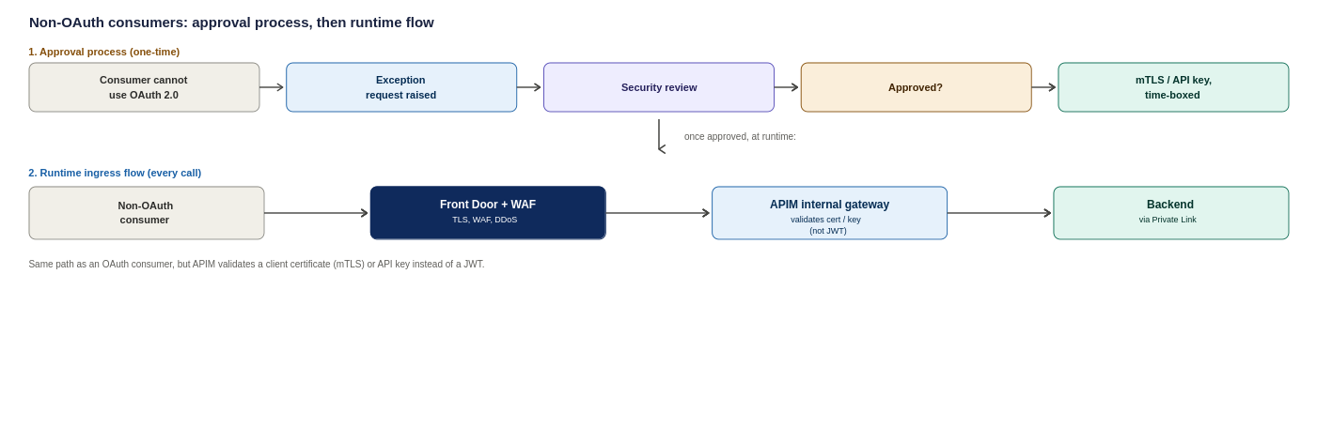
Figure 11: Non-OAuth consumers, the one-time approval process and the resulting runtime ingress flow
Aspect | Requirement
Who approves | Joint approval by the Security lead and the API Platform lead: not the requesting team alone
Compensating controls required | mTLS or a strict IP allow-list, plus a short-lived secret with enforced rotation; least-privilege product scope
Maximum validity | Time-boxed (recommended 12 months): an exception expires and must be re-approved, it does not roll over silently
Review cadence | Reviewed at least quarterly against continued need and the partner’s ability to move to OAuth
Record | Logged in a standing exception register with owner, justification, controls, approval date and expiry; referenced in the assumptions register (A.16)
Exit | Each exception carries a target date and named owner for moving the consumer onto OAuth

The diagram below adapts Microsoft's Protect APIs with Front Door and API Management reference architecture, showing how external and internal traffic are split at the edge before either ever reaches APIM.

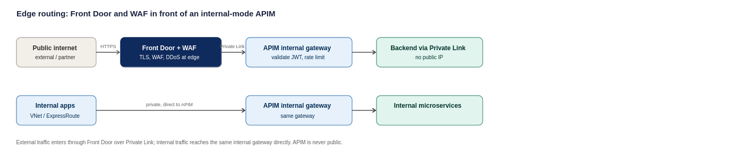
Figure 12: Edge routing pattern, adapted from Microsoft's Protect APIs with Front Door and API Management reference architecture
How each consumer type proves who they are
Consumer | How they authenticate | Backup control
Broker or partner | OAuth 2.0 token from Entra ID, validated on every call | Subscription key, IP allow-list where fixed egress IPs exist
Lloyd's market system | OAuth 2.0, with mutual TLS where the market requires certificate-based trust | Subscription key
Internal Organization system | Managed Identity, no secret ever stored or typed | Entra ID conditional access on the calling service
Inbound webhook from a vendor | Shared secret header, checked against Key Vault | IP allow-list restricting the source range

OAuth 2.0 flow at the gateway
Client credentials and authorization code flows are both enforced at the gateway using tokens issued by Entra ID. The backend never sees or validates a raw credential, only a pre-verified, policy-enforced token.
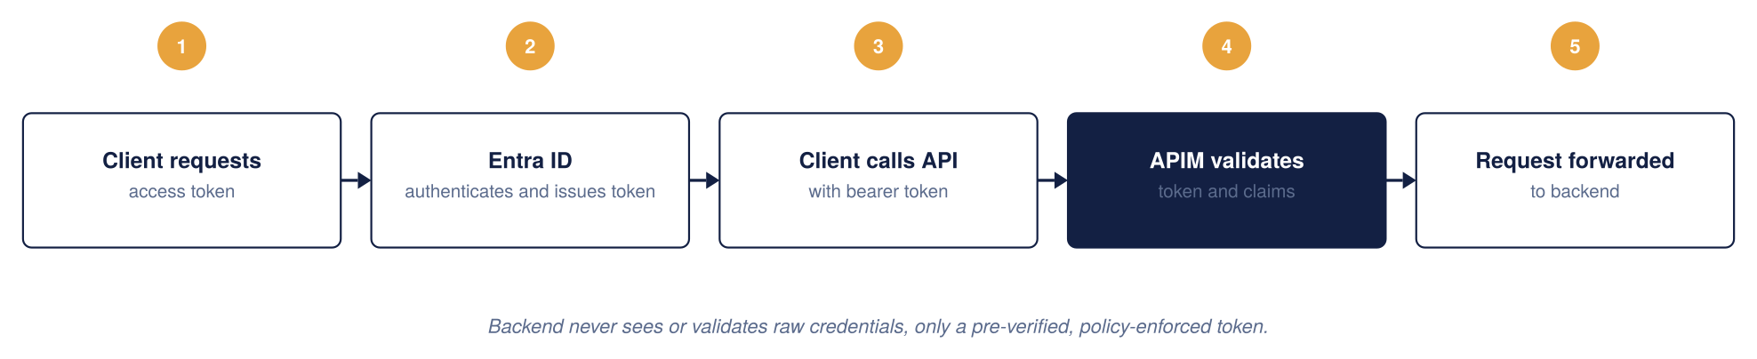
Figure 13: OAuth 2.0 architecture
JWT validation at the gateway
Every request is checked against four things before it is allowed through: signature, issuer and audience, expiry, and required claims or scopes. A failure on any of them is rejected with a 401 at the gateway; it never reaches the backend.
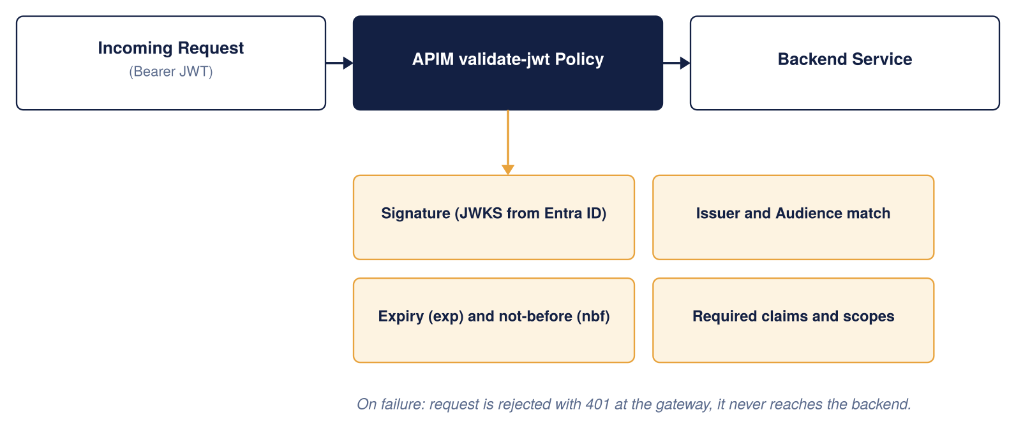
Figure 14: JWT validation architecture
Entra ID as the single identity provider
The same identity provider covers both API consumers and platform administrators, so there is one place, not two, where identity is managed.
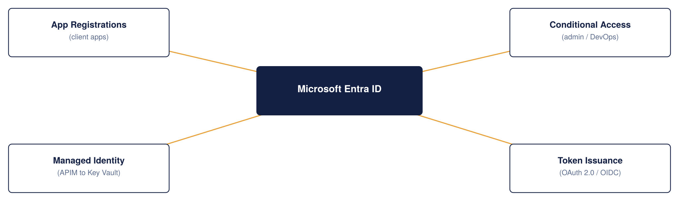
Figure 15: APIM and Entra ID integration
Secrets and certificate management
Azure Key Vault is the single source of truth for every secret, certificate, and key APIM depends on. Certificates rotate automatically; nothing sensitive is ever written into a policy file.
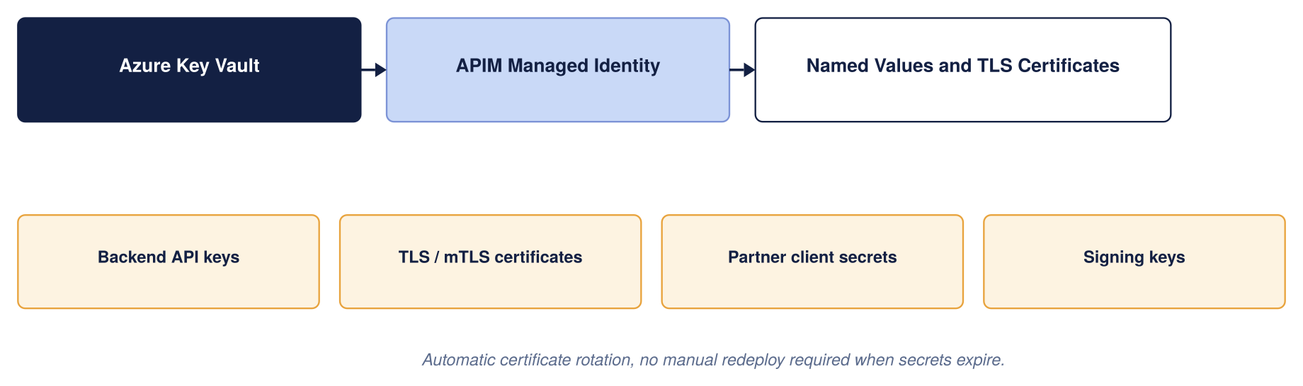
Figure 16: Secrets and certificates management
Which control owns what
These controls are layered deliberately, and they are not interchangeable. Each owns a distinct job, and the security of the whole depends on each doing its own rather than being treated as a substitute for another. The table makes the boundaries explicit so no control is assumed to cover a gap it does not.
Control | Primary responsibility
Microsoft Entra ID | Identity and authentication
OAuth 2.0 / JWT | Authorisation context per request
APIM | API gateway and policy enforcement
WAF (Front Door / App Gateway) | HTTP and API-layer attack protection
Azure DDoS Protection | Volumetric and network DDoS
Azure Firewall / NVA | Network segmentation and egress control
Private Endpoint | Private connectivity to backends
the Organization’s SIEM | Detection and investigation
APIM policies | Rate limits, quotas, validation, transformation

Partner and external identity
"External" is not one thing, and the identity model reflects that: the Organization’s external consumers span brokers, Lloyd's ecosystem participants, strategic partners, suppliers and third-party service providers, and no single pattern fits all of them.
The default and the exception path:
- Default: partner organisations are represented as Microsoft Entra External ID (B2B) identities where they can support it, with a per-partner app registration and subscription so access is granted and revoked per organisation.
- Exception: where a partner cannot use Entra, a brokered or federated identity, or certificate-based (mTLS) trust, is handled as an approved exception (see the exception process above).
- Open questions for the Organization’s identity team, not presumed by this design: who owns partner onboarding, who registers partner applications, and who rotates and revokes partner credentials. Recorded in the assumptions register (A.16 and the identity items).
Identity resilience and break-glass
Because the design leans heavily on Entra ID, it must also say what happens when Entra ID, or normal administrative access, is unavailable. This is a deliberate operational design point, not an afterthought. In practice this means four things, each needing the Organization’s identity and security teams to confirm the specifics:
- A documented break-glass process: a small number of emergency-access accounts held outside the normal flow, with their use alarmed and audited, so the platform can still be operated during an identity-provider outage without weakening the everyday model.
- Proactive tracking of certificate and secret expiry (the 30-day certificate-expiry alert in section 12 is part of this).
- A defined partner-credential revocation process.
- Clear ownership of the application-registration lifecycle. The specifics of the Organization’s break-glass standard need confirming with the identity and security teams; the requirement is stated here so it is not missed.
Important policy snippets
The standard reusable policy fragments (OAuth/JWT validation, per-subscription rate limit and quota, and managed-identity backend authentication) are held once in Appendix 17.4 and referenced from here rather than repeated. The one fragment kept inline is the non-OAuth exception pattern, because it belongs with the exception process above:

Restrict an inbound webhook to a known partner IP range and a shared secret. Note that shared-secret and IP-allowlist authentication is an approved exception pattern, not a peer of OAuth: it is used only where a partner genuinely cannot support anything stronger. The preferred order is OAuth 2.0 where supported, then mutual TLS where appropriate, then a signed HMAC webhook signature, and only then a shared secret plus IP restriction. Wherever the shared-secret pattern is used, the design still requires defined secret rotation, revocation, replay protection, monitoring and a named owner.
<inbound> <ip-filter action="allow"> <address-range from="203.0.113.0" to="203.0.113.255" /> </ip-filter> <check-header name="x-api-key" failed-check-httpcode="401" failed-check-error-message="Unauthorised: missing API key."> <value>{{webhook-api-key}}</value> </check-header> </inbound>

Regulatory and compliance alignment
The alignment above is deliberately honest that it is not yet Organization-verified. To make it something Compliance can actually sign rather than a narrative, the matrix below restates it as control area → Azure capability that delivers it → evidence artefact that proves it → owner. It is still proposed until Compliance confirms it against the Organization’s own control catalogue, but it is now in a form that can be confirmed line by line.
Control area (regulatory driver) | Azure capability | Evidence artefact | Owner
Access control & authentication (FCA SYSC; UK GDPR) | Entra ID OAuth 2.0, gateway JWT validation, control-plane RBAC | Entra sign-in/audit logs; policy config in Git; access-review records | Identity + Compliance
Encryption in transit (UK GDPR; Lloyd’s) | TLS 1.2+, Front Door, Private Endpoints | TLS/WAF configuration export; Private Endpoint inventory | Platform + Security
Audit & traceability (FCA; PRA operational resilience) | Log Analytics, App Insights, correlation IDs | Retained gateway logs; SIEM ingestion evidence; sample correlation-ID traces | Platform + Security
Threat protection | Front Door WAF, Azure DDoS, Defender for APIs | WAF rule set and logs; Defender for APIs findings report | Security
Availability & operational resilience (PRA; Lloyd’s) | Multi-region active-active, availability zones, Front Door failover | DR test reports; SLA evidence; TDA architecture sign-off | Platform
Secrets management | Key Vault-backed named values | Key Vault RBAC/access policy; secret-rotation records | Platform + Security
Data residency (UK GDPR) | UK South / UK West only | Region configuration; Azure Policy allowed-locations assignment | Platform + Compliance
Change control (FCA SYSC) | APIOps, pull-request review, approval gates | PR history; pipeline approval records | Platform
Data minimisation & PII (UK GDPR) | Payload logging off + redaction; data classification | Logging-policy configuration; DPIA reference | Compliance + Security
This matrix is the artefact Compliance signs; the regulatory references are indicative and must be reconciled with the Organization’s obligations register before go-live.
As a Lloyd's market insurer, the Organization operates under FCA and PRA regulation and, for market-facing integrations, Lloyd's own requirements, alongside UK GDPR for personal data. This design does not attempt to certify compliance, which is the Organization’s responsibility and a detailed-design activity, but it is built to support the controls those regimes expect. The table below maps each obligation to how the platform is positioned to meet it, and to what still needs Organization input. This is the area of the design most dependent on the Organization’s own standards, and it should be treated as a set of requirements to confirm rather than settled controls.
Obligation | How the design supports it | Still needed from the Organization
Data residency (FCA/PRA, UK data) | Primary and secondary regions both in the UK (UK South, UK West); no data leaves the UK by default | Confirm UK-only residency is sufficient and that no backend or SaaS dependency egresses data abroad
Personal data protection (UK GDPR) | TLS 1.2 in transit; payload masking possible at the gateway; PII kept out of verbose logs (Dev-only tracing) | Data Protection Impact Assessment; confirm what PII flows through which APIs
Audit trail and retention | Every request logged with a correlation ID; security events routed to the Organization’s SIEM | Confirm required retention periods against FCA/PRA record-keeping rules
Access control and segregation of duties | Entra ID identity for every consumer and admin; workspace-scoped RBAC; APIOps change approvals | Map to the Organization’s existing joiner-mover-leaver and SoD policies
Lloyd's market trust | Mutual TLS available where the market requires certificate-based trust; per-partner subscriptions and revocation | Confirm specific Lloyd's connectivity and certificate requirements per counterparty
Operational resilience (PRA/FCA) | Zone-redundant HA and multi-region DR with stated RTO/RPO targets | Agree RTO/RPO against the Organization’s operational-resilience impact tolerances

The position is that compliance is the least Organization-verified part of this HLD: the platform is designed to make these controls achievable, but none can be signed off without the Organization’s compliance and data-protection teams confirming the specifics. This is called out again in the assumptions register (section 16).

API Product, Consumer and Developer Portal Model
Once APIM is live, the Organization needs a way for different teams to manage their own APIs without stepping on each other, while the platform team keeps one place to see and control everything. Workspaces, products, subscriptions, and groups fit together like a filing cabinet: workspaces are the drawers, products are the folders, subscriptions are the individual keys handed out, and Entra ID groups decide who can open which drawer.
Choosing each layer: a clear strategy for Products, Consumers and the Portal
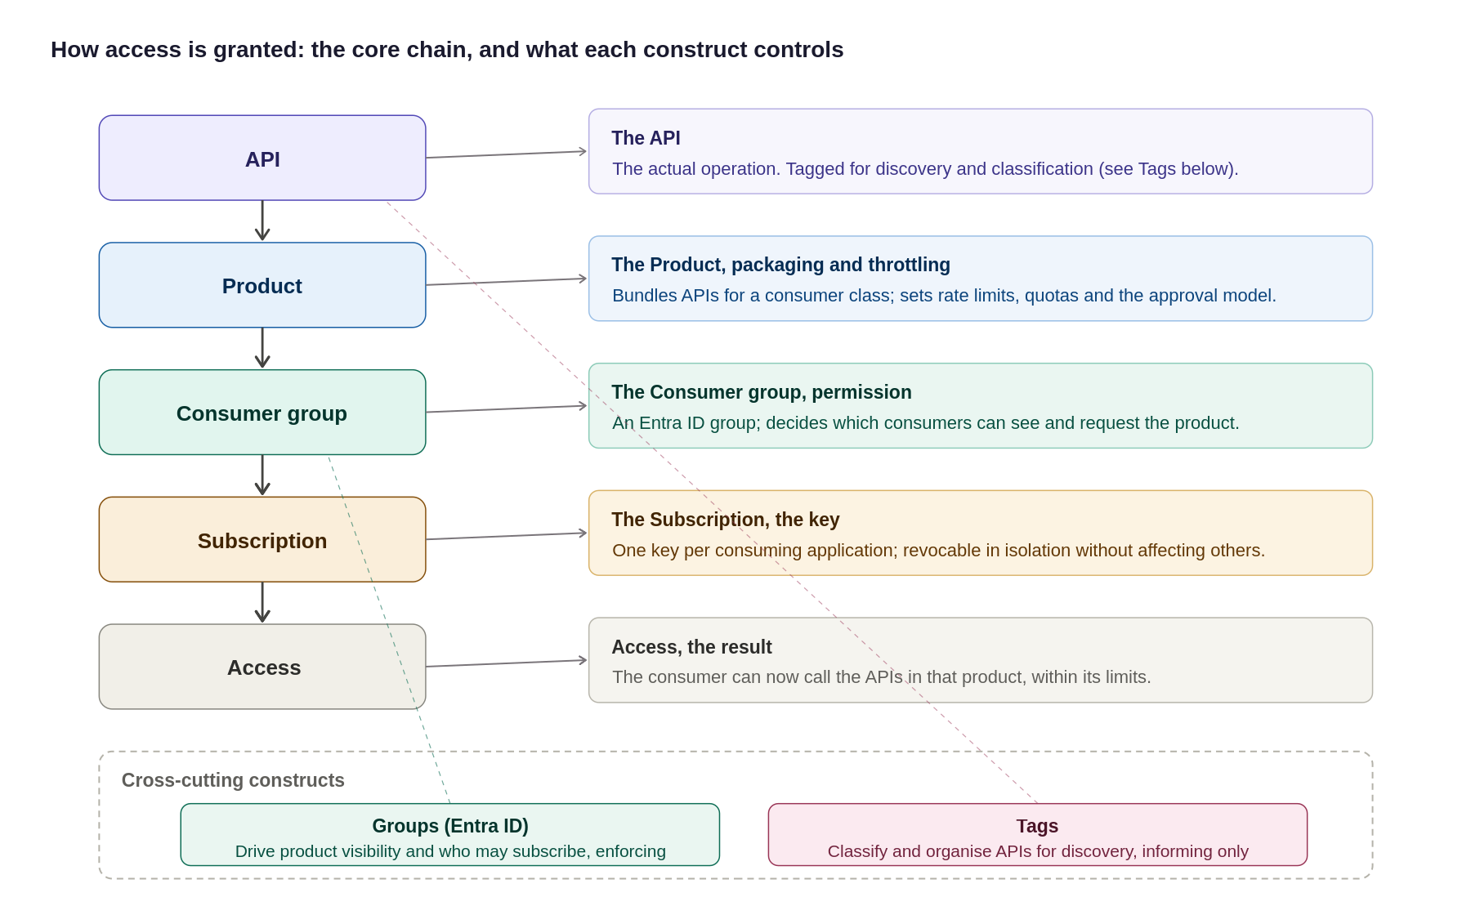
Figure 17: The access model, the core chain plus what each construct controls, including Groups and Tags
In summary:
Layer | The question it answers | The strategy
Product | “Which APIs does this consumer class get, and under what rules?” | One product per consumer class; APIs bundled into it; policy, quota and approval set at product scope
Consumer / subscription | “Who is calling, and how is access granted and revoked?” | Entra ID group per organisation/team; one subscription per application; no local APIM users
Developer portal | “How does a consumer discover, subscribe and test without a ticket?” | SSO on, self-registration off, group-filtered catalogue; portal is the only self-service surface

How the governance constructs fit together: the diagram below shows the hierarchy from the APIM instance down through workspaces, products and subscriptions, with Entra ID groups controlling access via RBAC.
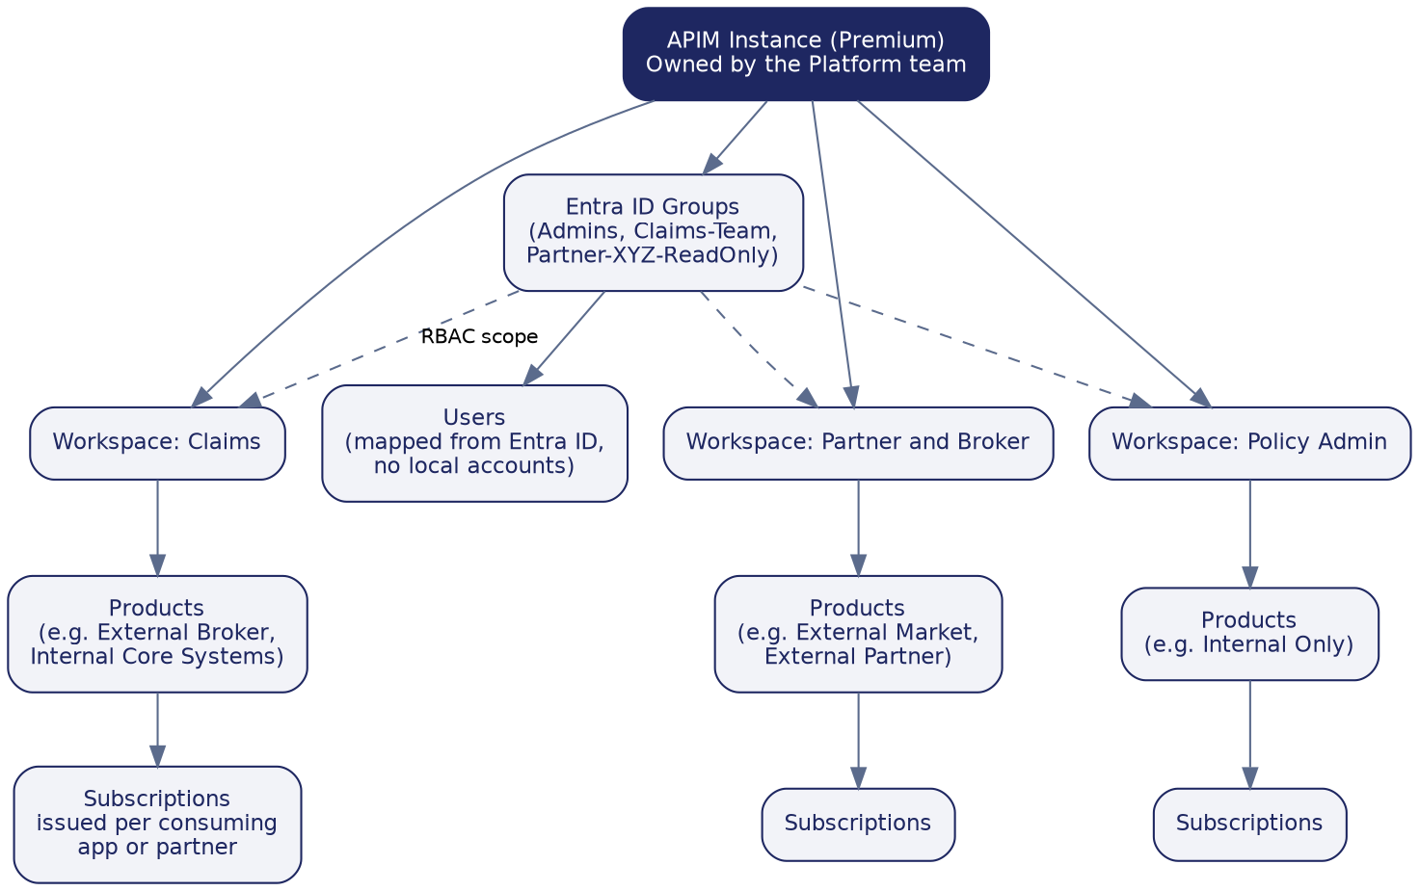
Figure 18: Recommended workspace, product, subscription, and group structure

Products, subscriptions, groups and users
- Products group related APIs and carry the access rule for that group, for example an External Broker product bundling every API a broker may call.
- Subscriptions are individual keys issued per consuming application or partner, so one consumer's access can be revoked without affecting anyone else.
- Groups map to Entra ID, never to local APIM accounts, so a broker's technical team or the platform administrators are each represented by one Entra ID group.
- Users are never created directly inside APIM; access always flows from an Entra ID identity through a group, so the Organization’s existing joiner-mover-leaver process keeps APIM access correct automatically.
Backend governance constructs
Beyond the runtime architecture, APIM provides a set of backend constructs that decide how APIs are organised, secured, discovered, and extended over time. Used well, they let the Organization add and evolve API capability without the platform becoming a tangle. Used poorly, they become the tangle. This section explains each construct and how the Organization should use it. The constructs build on one another: named values feed policies, products group APIs and attach policies, groups decide who sees a product, tags make everything discoverable, and workspaces let teams own their slice of all of the above.
Named values
Named values are APIM's key-value store for configuration and secrets that policies reference by name rather than hard-coding. A named value can hold a plain setting (a backend URL, a rate-limit ceiling, a feature flag) or a secret, and a secret named value can be backed directly by Azure Key Vault so the actual secret never lives in APIM at all and rotates automatically when it changes in the vault.
The purpose is twofold: keep sensitive material out of policy XML, and keep environment-specific configuration in one place so the same policy works unchanged across Dev, UAT and Production. Typical uses at the Organization:
- Key Vault-backed secrets: the webhook shared secret, partner client secrets, and signing keys referenced by policies but stored and rotated in Key Vault.
- Environment configuration: backend base URLs and timeouts that differ per environment, so promotion through APIOps changes the named value, not the policy.
- Reused constants: a standard rate-limit ceiling or a tenant ID referenced by many policies, changed once in one place.
Governance rule: no secret is ever typed into a policy; it is always a Key Vault-backed named value. Named values are themselves environment-scoped and version-controlled through APIOps, so a reviewer can see what changed.
Products
A product bundles one or more APIs under a single set of access rules, and it is what consumers actually subscribe to (never an API directly). Each product carries its own policies (rate limits, quotas), its own visibility (which groups can see it), and its own approval model (automatic or sign-off).
This is how consumer classes are separated cleanly. The product set mirrors the consumer model:
- External-facing products, for example External Broker, External Market and External Partner, each bundling only the APIs that class of partner may call, with stricter rate limits and manual subscription approval.
- Internal products, for example Internal Core Systems and Internal Data Platform, with higher limits and automatic approval for trusted internal consumers.
Because product policy sits above API policy, a product is where rules that apply to a whole consumer class are enforced once, not repeated per API.
Groups
Groups control who can see and subscribe to which products, through group membership: a broker’s group sees only broker products. The key point: custom groups map to Microsoft Entra ID, not to local APIM accounts.
This keeps access governance in one place: each team is an Entra ID group, joiners and leavers are managed through the existing Entra ID process, and APIM visibility follows automatically. No access is ever granted by creating a user inside APIM.
Tags
Tags are free-form labels on APIs and products for categorisation and discovery only, they enforce nothing. Consumers filter and search by tag in the portal, and the platform team reports on the estate by tag.
Agree a small, consistent tag taxonomy up front, useful dimensions are business domain, consumer audience, lifecycle status and data sensitivity. A tag is discoverability, not a control: a sensitivity tag flags an API for review, it does not secure it.
Workspaces
Workspaces let the Organization decentralise day-to-day API management without losing central control. A workspace is a self-contained slice of the APIM instance (its own APIs, products, subscriptions, named values, tags and policies) that a team manages via scoped Azure RBAC, while the platform team keeps the shared infrastructure, networking, monitoring and global policy. It is the federated model: central governance, delegated development.
the Organization’s split is one workspace per business domain that owns integrations. The matrix below defines each planned workspace, who owns it, what it does, and the governance boundaries that apply. Workspaces are a Premium-tier capability, which aligns with the tier recommendation in section 15.
Workspace | Owner / audience | Primary function | Governance boundary
Claims | Claims domain team | Publish and manage claims-related APIs, products and subscriptions | Team owns everything inside via workspace-scoped RBAC; platform team owns shared infrastructure, networking and global policy
Policy Admin | Policy administration team | Publish and manage policy-administration APIs | Same federated boundary; names unique across the whole service, so domain-prefix API/product/tag names
Finance | Finance domain team | Publish and manage finance and billing APIs | Workspace policy cannot reach service-level named values or backends; shared config promoted in via APIOps
Partner and Broker | Partner integration team | Publish and manage partner- and broker-facing APIs | No service-level managed identity inside the workspace; use a user-assigned identity or handle backend auth at service level
All four run on the built-in gateway (not dedicated workspace gateways), because the design depends on multi-region, Private Link and custom hostnames, which dedicated gateways do not currently support. The gateway, sizing and constraint decisions are set out just below.
Refining the workspace strategy: gateway model, sizing and constraints
The one-workspace-per-domain split above needs three decisions to make it buildable: which gateway a workspace runs on, how many workspaces to create, and which platform constraints to design around.
Gateway model: use the built-in gateway, not dedicated workspace gateways. A workspace’s runtime can run on either the instance’s built-in (default managed) gateway or a separate, dedicated workspace-gateway resource. Dedicated gateways give stronger runtime isolation between domains, but they do not currently support multi-region deployment, Private Link, or custom hostnames, and they add cost, a separate scale surface, and a provisioning step that can take several hours. Because the Organization’s design depends on exactly those three capabilities: multi-region (14), Private Link origin from Front Door (6), and custom hostnames: workspaces should be associated with the built-in gateway, which now supports workspaces and inherits all of those features. Dedicated workspace gateways are held in reserve for a future domain that needs hard runtime isolation and can accept the multi-region/Private Link trade-off.
Sizing: one workspace per domain that owns integrations, not per team or per API. The starting set stays Claims, Policy Admin, Finance, and Partner and Broker. The guardrail is ownership: create a workspace only where a distinct team will own the APIs, products and subscriptions inside it through their whole lifecycle. Splitting more finely than ownership creates administrative overhead without governance benefit; a workspace gateway can carry many workspaces (up to 30 as a shared gateway) so there is headroom, but the number should track real team boundaries, not be maximised.
Constraints to design around. Three platform boundaries shape the model and should be reflected in build standards: names are unique across the whole service, so two workspaces cannot share an API, product or tag name even though they are otherwise isolated; workspace policies cannot reach service-level named values or backends by name, so anything shared must be provided within the workspace or promoted into it through APIOps; and service-level managed identities are not available inside workspaces, which affects the “call the backend using Managed Identity” pattern: workspace-scoped APIs must use a user-assigned identity made available to the workspace, or have that backend authentication handled at service level. Each of these is a build-time rule, not a blocker.
The workspace decisions in one place:
Decision | The constraint | The Organization position
Gateway | Dedicated workspace gateway vs built-in gateway | Built-in gateway: it is the only option that keeps multi-region, Private Link and custom hostnames
Number | One per team-owned domain | 4 to start (Claims, Policy Admin, Finance, Partner & Broker); add only when a new owning team appears
Naming | Names unique across the whole service | Prefix API/product/tag names by domain to avoid collisions between workspaces
Shared config | Workspace policy cannot see service-level named values/backends | Provide shared named values within each workspace via APIOps promotion
Identity | No service-level managed identity inside workspaces | Use a user-assigned identity for workspace backend auth, or handle at service level

How the constructs fit together
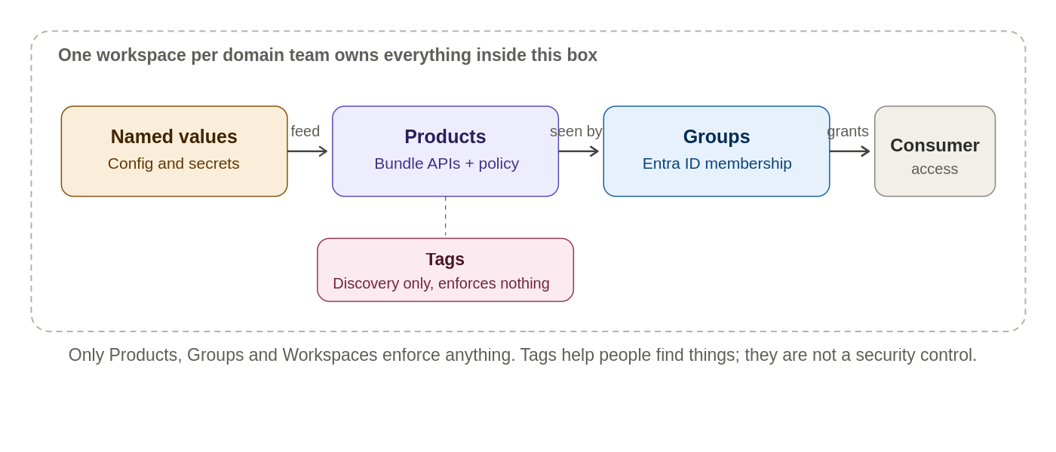
Figure 19: How the governance constructs relate to each other
Construct | Governs | Enforces or informs
Named values | Configuration and secrets used by policies | Enforces (Key Vault-backed, environment-scoped)
Products | Which APIs are bundled and their access rules | Enforces (policy, quota, approval)
Groups | Who can see and subscribe to a product | Enforces (via Entra ID membership)
Tags | Categorisation and search | Informs (discoverability only)
Workspaces | Which team owns which APIs | Enforces (RBAC-scoped isolation)

Developer portal
Purpose
The developer portal is APIM’s self-service front door for the people who consume APIs, an automatically generated, customisable website that publishes the API catalogue, its documentation, and the means to subscribe and test. Its purpose is to let a developer discover and adopt an Organization API without a ticket or a conversation. APIM has two audiences: the platform and domain teams work in the management plane (portal, CLI, APIOps) to define APIs, products and policies; the consuming developers, internal or partner, live in the developer portal. Nothing a consumer needs to self-serve should live anywhere else.
API discovery strategy
Discovery is deliberately curated, not a raw API list. Three rules shape what a developer finds:
- Visibility follows identity: the portal shows only the products a signed-in developer’s Entra ID group permits, so a broker sees broker products and never an internal-only API.
- Grouping is by product, not raw API: a developer opens a product tile (for example External Broker), sees the APIs it bundles, and subscribes to the product as a unit; the subscription then works across every API in it.
- Tags are the search axis: consistent tags (section 10) let developers filter and search a growing catalogue, and each API page carries its operations, request and response schemas, and an interactive console for trying a call.
User onboarding flow
The end-to-end path for bringing a new broker, partner or internal team onto the platform through the portal:
- Access: the consumer is added to the appropriate Entra ID group; sign-in is through single sign-on, and self-registration is disabled, so access is always deliberate.
- Discover: signed in, they see only the products their group permits, and browse the APIs and documentation within them.
- Subscribe: they request a subscription to the product they need, automatic for trusted internal products, gated by approval for external ones.
- Credentials: on approval a subscription key is issued, and for OAuth-protected APIs their application obtains a token from Entra ID; the backend never sees a raw credential.
- Test and integrate: using the interactive console and published schemas, they validate their calls, then integrate against the stable published contract rather than a specific backend.
In steady-state production the same consumer calls the API through APIM, where JWT validation and per-subscription rate limits and quotas are enforced on every call, and manages their own subscriptions and key rotation from the portal profile area without an Organization ticket. The full journey, from access granted to steady-state use, is shown below.
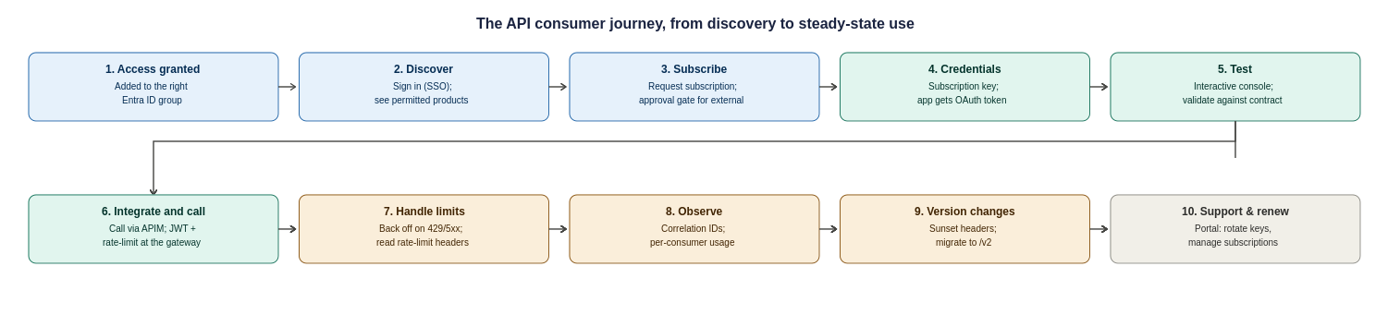
Figure 20: The API consumer journey, ten steps from access granted to steady-state use, support and versioning
Two responsibilities sit with the Organization to make this journey real, and are recorded as operational tasks in the assumptions register: a named owner for approving external subscription requests within an agreed SLA, and a defined support and escalation path (who a partner contacts when a call fails, and how correlation IDs are used to resolve it).

API Design, Policies and Governance

Engineering and Naming Standards
These engineering standards are not invented for this platform; they follow the Organization’s existing Engineering Standard and Cloud Adoption Framework conventions, and are restated here only where they bear on the APIM design. Where this document and the corporate standard differ, the corporate standard prevails and this design should be reconciled to it. [Placeholder: link to the Organization’s Engineering Standard / CAF naming standard: to be inserted by the Organization before issue.]
APIs follow the design and naming standards below; these are the engineering standards the platform enforces.
Every API follows the same conventions, so teams and consumers do not have to relearn a new shape for every integration.
Aspect | Standard | Example
Base path | /api/{domain}/{version}/{resource} | /api/claims/v1/claims
Resource naming | Plural nouns, lowercase, kebab-case | /api/policies/v1/policy-holders
Versioning | URL path, major version only for breaking changes | /api/claims/v2/claims
Response format | Consistent data / error / metadata envelope with a correlation ID | See Appendix 17.4

Design Standards, Policy Enforcement and Governance
Target operating model and RACI
Governance only works if ownership is unambiguous. The model is a federated one: a central Platform team owns and runs the shared APIM platform and its guardrails, while Domain teams own the APIs inside their workspace; Network, Identity, Security and Compliance own their respective controls across all domains. The RACI below fixes who is Responsible, Accountable, Consulted and Informed for the activities that recur.
Activity | Platform | Domain | Network | Identity | Security | Compliance
Run the APIM platform (upgrades, capacity, guardrails) | A/R | I | C | C | C | I
Design & build an API | C | A/R | I | I | C | I
Onboard & publish an API (gates) | A/R | R | I | C | C | I
Baseline policy & security configuration | A/R | C | I | C | C | I
Network changes (UDR/NSG/DNS/firewall) | C | I | A/R | I | C | I
Identity groups & app registrations | C | C | I | A/R | C | I
Security controls & threat monitoring | C | I | C | C | A/R | C
Compliance evidence & sign-off | C | I | I | I | C | A/R
Deprecation & partner migration | A/R | R | I | I | I | I
Incident response | A/R | C | C | C | R | I
R = Responsible (does the work), A = Accountable (owns the outcome), C = Consulted, I = Informed. Named individuals for each accountable role are to be recorded by the Organization against this table before go-live.
APIM policies apply at four levels, and the most specific one always wins: Global, then Product, then API, then Operation. The Organization should keep global policies to the handful that must never be skipped everywhere (correlation ID, HTTPS enforcement, header stripping), and push everything consumer-specific down to Product level, where it belongs.
Rather than let each team write policies from scratch, the platform ships a small library of reusable policy fragments that are referenced by name, so a fix to the standard JWT-validation fragment updates every API that includes it. The matrix below shows which standard policy applies at which scope. The full policy snippets themselves are in Appendix 17.4.
Policy | Scope | Purpose
Correlation ID injection | Global | Stamp every request with a trace ID carried through to the backend and logs
HTTPS and TLS 1.2 enforcement | Global | Reject any non-TLS or outdated-protocol request outright
Sensitive header stripping | Global | Remove internal headers before a response leaves the gateway
JWT validation | Product | Check token issuer, audience, expiry and scope per consumer group
Rate limit and quota | Product | Cap each subscription so one consumer cannot exhaust the platform
Managed identity to backend | API | Authenticate to the backend with no stored secret
Response caching | Operation | Cache safe, cacheable GETs where the backend allows it
IP allow-list and shared secret | Operation | Lock a specific webhook operation to a known source

This keeps the number of distinct policies small and consistent: a reviewer can see at a glance what is enforced everywhere versus what is specific to one consumer or one operation, which is the point of a policy design rather than a pile of per-API XML.
Governance matters as much as structure: the value of a shared policy library is lost if any team can quietly override a global control at a lower scope. The design therefore assigns clear ownership, and treats global security policies as protected, changeable only through the platform and security owners rather than by an individual API team. Who owns each policy area is set out below; the exception-approval row is the control that stops a lower scope silently weakening a global rule.
Policy area | Owner
Authentication | Platform / Security
Rate limiting | API Platform
Security headers | Platform / Security
Transformation | API team
Consumer-specific quota | Product / API owner
Logging | Platform / Security
Exception approval | Architecture / Security
RBAC role assignments (to confirm with the Organization’s Identity and Platform teams)
Policy ownership above states who is accountable for each area; the table below maps that to the actual Azure role each group needs, so an implementer can create the role assignments directly rather than infer them. All assignments are scoped as narrowly as the built-in roles allow, and none are assigned to individuals, only to Entra ID groups.
Scope | Azure role | Assigned to
APIM service (full control) | API Management Service Contributor | Platform team break-glass group only (section 8); day-to-day changes flow through APIOps, not this role
Workspace (per business domain) | API Management Workspace Contributor / API Management Workspace API Developer | Domain team Entra ID group for that workspace (Claims, Policy Admin, Finance, Partner and Broker)
Named values and secrets | API Management Service Contributor scoped to named values, plus Key Vault Secrets User on the backing vault | Platform / Security group only; never assigned at workspace scope for Key Vault-backed secrets
APIOps pipeline service principal | API Management Service Contributor (or workspace-scoped equivalent for workspace-only pipelines) | Pipeline service connection / managed identity, not a human account
Read-only estate visibility | API Management Service Reader | Architecture, security and audit groups who need to see configuration without changing it
Resource group / networking | Network Contributor (subnet and NSG scope only) | the Organization’s Network team, scoped to the APIM subnet, not the wider hub
This table proposes a starting model; the exact built-in role names should be validated against the current Azure role definitions at build time, since Microsoft periodically introduces more granular workspace-scoped roles.

A small, empowered governance board sets the standards; automation enforces them so governance never becomes a bottleneck.
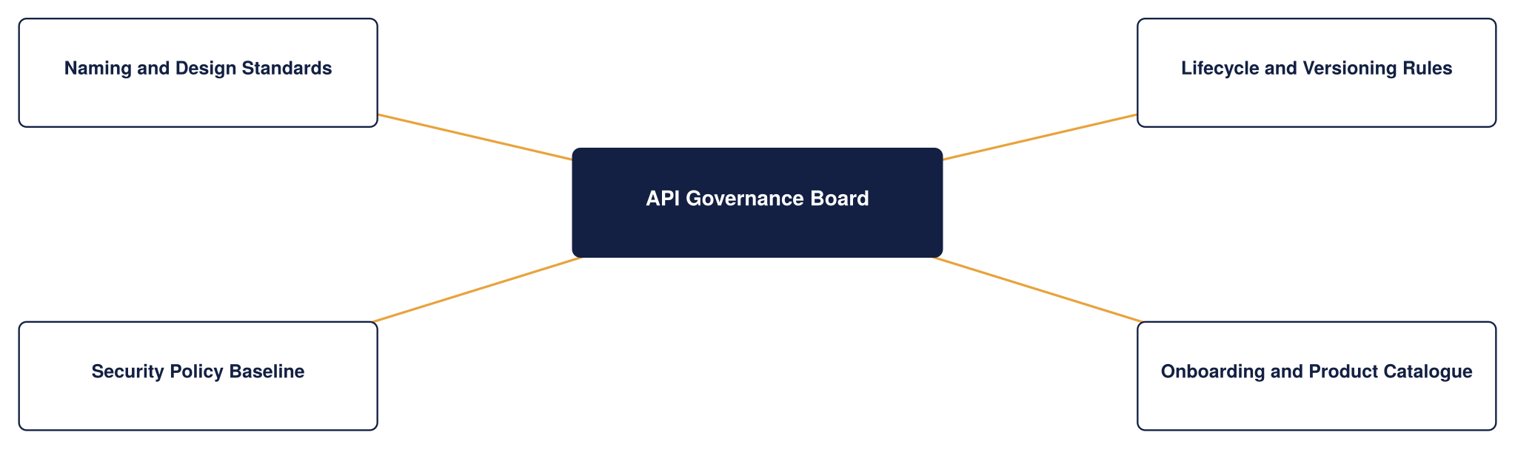
Figure 21: API governance framework
Onboarding a new API
This section describes the end-to-end path for bringing a new API onto the platform using the governance constructs above, so that every API added to the Organization’s estate is consistent, discoverable, secured and owned from day one. It ties together naming, product and group assignment, tagging and workspace placement into one repeatable process rather than a series of ad hoc choices.
The end-to-end flow
The diagram below shows the end-to-end onboarding path at a glance; the steps beneath it describe each stage in detail.
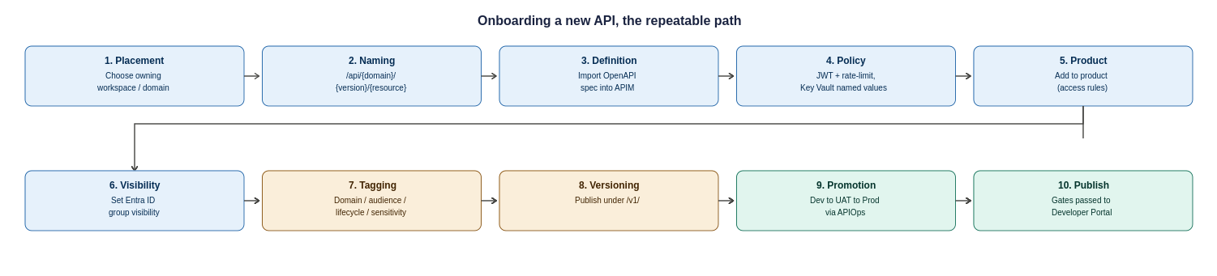
Figure 22: Onboarding a new API, the ten-step repeatable path from placement to publication
- Placement: decide which workspace owns the API, based on the business domain (Claims, Policy Admin, Finance, or Partner and Broker). The owning domain team, not the platform team, drives the rest of the process within that workspace.
- Naming: apply the naming convention from section 10.1, so the API's path follows /api/{domain}/{version}/{resource} with plural, lowercase, kebab-case resources. Consistent naming is what makes the estate navigable and routable.
- Definition: import or author the API (typically from an OpenAPI specification), which brings its operations and request and response schemas into APIM.
- Policy: attach the standard policy set at the right scope, JWT validation and rate limits at product level, managed-identity backend auth at API level, referencing Key Vault-backed named values rather than inline secrets.
- Product assignment: add the API to the appropriate product (for example Internal Core Systems or External Broker), which determines its access rules and which consumers can subscribe.
- Group visibility: confirm the product's visibility is set to the correct Entra ID groups, so only the intended audience sees it in the developer portal.
- Tagging: apply the agreed tags, business domain, audience, lifecycle status and any sensitivity flag, so the API is discoverable and reportable from the moment it is published.
- Versioning: publish under an explicit version (for example /v1/) using the strategy in section 11, so future breaking changes can be introduced as /v2/ without disruption.
- Promotion: move the API through Dev, UAT and Production via the APIOps pipeline, reviewed and deployed as code, never hand-configured in Production.
- Publication and governance: pass the design and security gates from section 10.2, then publish to the developer portal. The API is now live under an owner, in a product, visible to the right groups, tagged, versioned and monitored.

API Onboarding checklist
Step | Governance construct | Outcome
Assign to workspace | Workspace | Clear domain ownership
Apply naming convention | Design standard | Consistent, routable path
Attach standard policies | Named values, policy scope | Secured with no inline secrets
Add to product | Product | Access rules and subscribers defined
Set product visibility | Groups (Entra ID) | Only the intended audience sees it
Apply tags | Tags | Discoverable and reportable
Publish under a version | Versioning | Future changes are non-breaking
Promote via APIOps | Environments | Consistent across Dev, UAT, Prod

Followed each time, this process means growth does not erode governance: the hundredth API onto the platform is organised exactly like the first.
Onboarding service levels (time-to-first-API)
The onboarding steps above have owners and target cycle times so “time-to-first-API” is a committed number rather than an open-ended process. The targets below are for a straightforward API on the happy path; complex or high-sensitivity APIs will take longer and that is expected.
Stage | Owner | Target cycle time
Intake & placement (workspace, ownership) | Platform | 2 business days
Design & naming review | Domain + Platform | 3 business days
Security review (classification, auth, policy) | Security | 3 business days
Build & policy in Dev | Domain | Domain-dependent
Promotion through gates to Production | Platform | 1 business day per gate
Overall time-to-first-API (simple API, happy path) | : | ~10 business days
These targets should be tracked as an operational metric; persistent breaches are a signal to simplify a gate, not to skip it.

API Lifecycle and Versioning Strategy
Every API on the platform follows the same seven-stage lifecycle, from first design through to retirement, with no manual hand-off between stages and usage analytics from the Monitor stage feeding back into the next design cycle. This section explains what happens at each stage, then sets out how versioning keeps changes non-breaking as an API evolves.
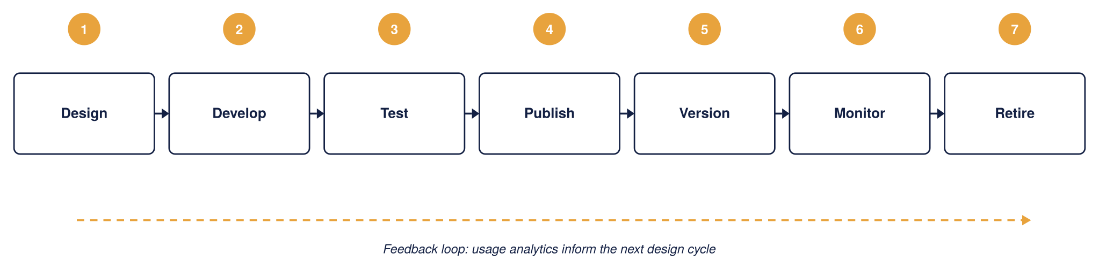
Figure 23: API lifecycle management, the Organization
The seven stages, what each one does, and who owns it:
Stage | What happens | Owner
1. Design | Define the API contract (OpenAPI), naming and schema; check against design and naming standards before any build | Domain team
2. Develop | Build the API and its policies as code, referencing Key Vault-backed secrets, never inline credentials | Domain team
3. Test | Run automated policy and contract tests in Dev/UAT; nothing proceeds until these pass | Domain team
4. Publish | Promote through the APIOps pipeline and publish to the developer portal under an approved product, visible only to the right groups | Platform team
5. Version | Introduce changes safely: additive changes as a new revision, breaking changes as a new version (v2) alongside v1 | Domain team
6. Monitor | Track usage, errors, latency and quota consumption per consumer; feed findings back into the next design cycle | Operations / SRE
7. Retire | Deprecate with a Sunset header and a defined notice window, then remove; the gateway returns 410 Gone, never a silent removal | Platform + Domain
In practice these stages map onto concrete gates: intake registers the API and its intended consumers, design review checks schema and naming standards, a security gate confirms scopes and rate limits, pre-production sign-off requires automated policy and contract tests to pass, and production publish makes the API visible in the developer portal under an approved product. Retirement follows a defined deprecation notice and sunset window rather than a silent removal. The full step-by-step onboarding path that walks a new API through these stages is in section 11 (Onboarding a new API).
Versioning: keeping change non-breaking
Versioning exists so that the Organization can improve an API without breaking the systems already calling it. The design uses two distinct APIM mechanisms for two distinct situations, and it is worth being precise about which is which, because they are often confused.
Mechanism | When it is used | Consumer effect
Revision | A change that does not break the contract, for example adding an optional field or fixing a bug | Consumers keep calling the same URL; the new revision can be tested online, then made current
Version | A change that breaks the contract, for example removing a field or changing a type | A new version (v2) is published alongside v1; consumers move when they are ready

Versions are expressed in the URL path (for example /api/claims/v1/ and /api/claims/v2/), which is the clearest scheme for partners to read and the easiest to route on at the gateway. APIM also supports header-based and query-string versioning; path-based is the house standard here, with the others available only where a specific partner integration requires them.
The table below sets out how each kind of change is handled and what the consumer experiences.
Change type | Versioning approach | Consumer impact
Breaking change | New major version, for example /v2/, published alongside /v1/ | None until the consumer opts in
Non-breaking addition | Same version, new revision, additive fields only | Zero impact, backward compatible
Deprecated version | Marked deprecated in the Developer Portal; a Sunset response header advertises the retirement date | 90-day minimum notice period
Retired version | Removed after the sunset window; the gateway returns 410 Gone | Enforced by APIM policy, never a silent removal

The diagram below shows how a version transition plays out over time. A new version can be published as a preview while the current version is still live, the current version then enters a deprecation window of at least 90 days during which a Sunset header warns callers, and only after that window and confirmed consumer migration is it retired.
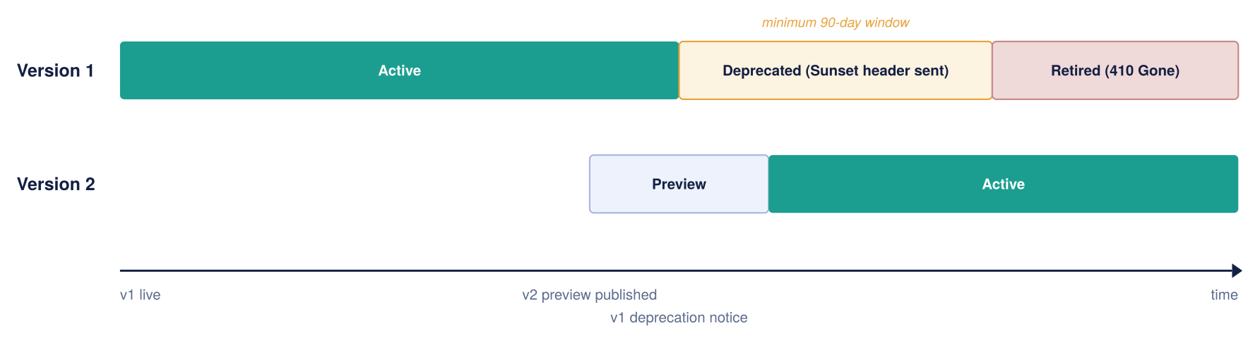
Figure 24: API version lifecycle over time
Deprecation is signalled in-band, not just in documentation: while a version is deprecated the gateway attaches a standard Sunset header (and, where useful, a Deprecation header) to every response, so a consumer's own tooling can flag the coming retirement automatically. This is what makes 'never a silent removal' enforceable rather than a promise.
Maintaining the lifecycle: deprecation, Sunset and retirement
Every published API is treated as having a full lifecycle, not just a launch. The mechanics below make each transition explicit and machine-readable, so consumers are never surprised and retirement is always a planned event.
Publish and run. A new version is published under an explicit path segment (/v1/, /v2/) and made visible in the Developer Portal under the product that governs it. While a version is current it is monitored through the same observability stack (section 12), and non-breaking changes are shipped as revisions against the same version so consumers keep calling the same URL.
Deprecate. When a breaking change requires a new version, the outgoing version enters a deprecation window of at least 90 days. During this window the gateway attaches a standard Sunset HTTP header (RFC 8594) to every response, giving the exact date the version will stop being served, and, where useful, a Deprecation header marking it as deprecated. Because these are response headers rather than documentation, a consumer’s own tooling can detect the coming retirement automatically. A policy fragment applied at the version scope adds the headers, so no per-API work is needed.
Notify and track. Deprecation is announced in the portal and, for external products, to the named technical contact on each subscription. The platform team tracks which subscriptions are still calling the deprecated version through per-consumer telemetry, so migration can be confirmed by data rather than assumed.
Retire. The version is removed only after the window has elapsed and telemetry confirms consumers have migrated. Retirement is a deliberate, logged step: never a silent removal: and the version’s routes return a clear gone/redirect response thereafter. All of this is driven from Git through APIOps, so a retired version is removed as reviewed code, not by a manual portal edit.
Operational ownership of deprecation. The headers and window make deprecation enforceable, but a person still owns the conversation. For every deprecation, the owning Domain team is responsible for the migration relationship with affected consumers, and the Platform team is accountable for the process being followed. For external partners this means: identify affected subscriptions from telemetry, contact the named technical and business contacts on each subscription, agree a migration date within the window, track progress, and escalate to the partner’s relationship owner if a consumer is not moving with the deadline approaching. Retirement proceeds only when telemetry confirms migration; if a critical partner genuinely cannot meet the date, an extension is a logged, approved decision, not a slipped deadline.
The headers attached during the deprecation window:
Header | Example value | What it tells the consumer
Sunset | Sunset: Sat, 30 Nov 2026 23:59:59 GMT | States the exact date/time the version stops being served (RFC 8594)
Deprecation | Deprecation: true | Marks the version as deprecated so tooling can flag it
Link (optional) | Link: <https://developer.organization.example/…/v2>; rel="successor-version" | Points callers at the version they should move to

Observability and Operations
Every gateway, policy, and backend call feeds into a single Azure Monitor view, so there are no blind spots between environments. Application Insights carries end-to-end tracing; Log Analytics holds the raw diagnostic logs; dashboards give operations, integration, security, and executive audiences the view each of them needs.
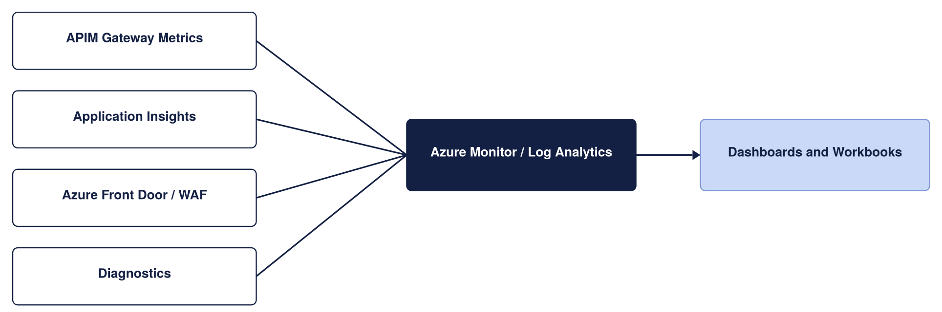
Figure 25: Monitoring architecture
What is actually logged, and where it goes, matters as much as the diagram. Each source emits structured telemetry through APIM's diagnostic settings, every record carries the same correlation ID so a single request can be followed end to end, and each stream lands in the sink suited to its purpose.
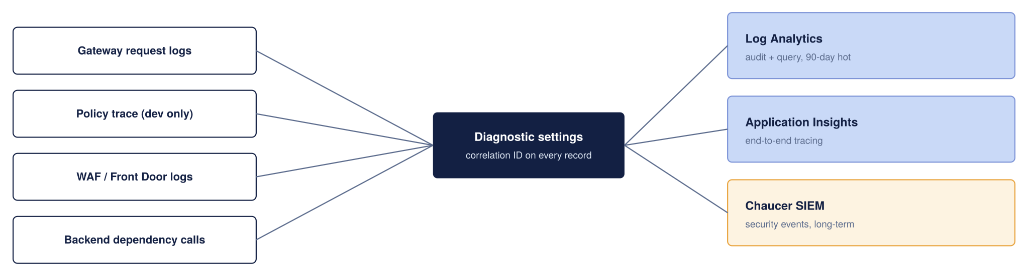
Figure 26: What is logged and where it goes
The retention periods below are proposed starting points to be reconciled with the Organization’s actual logging and data-retention standard, not confirmed values; the 90-day figures in particular should be checked against the Organization’s SIEM and compliance retention requirements.
Telemetry | Sink | Retention (proposed)
Gateway request and response metadata | Log Analytics | 90 days hot, then archived per the Organization’s log policy
End-to-end distributed traces | Application Insights | Sampled in production to control cost
Policy trace (verbose) | Application Insights | Enabled in Dev only; off in production by default
WAF and Front Door logs | Log Analytics | 90 days, feeding the security dashboard
Security-relevant events | the Organization’s SIEM | Long-term, per existing SIEM retention standard

Correlation IDs are propagated from the gateway to the backend, so a trace does not stop at APIM; a support engineer can follow one broker request from the edge, through the policy pipeline, into the backend and back. This propagation should be validated end to end during the pilot, since a correlation ID that is dropped by an intermediate hop breaks the trace. Verbose policy tracing is deliberately restricted to Dev, because it is expensive and can capture sensitive payload detail that has no place in a production log.
Dashboards are cut by audience rather than one generic view: an operations dashboard tracks latency, error rate and throttling; an integration dashboard tracks per-API and per-consumer volumes; a security dashboard surfaces 401s, WAF blocks and anomalous spikes; and an executive view rolls up availability against the SLA. The alert thresholds below are proposed defaults to be agreed with the Organization’s operations team, not fixed commitments; they are starting points for tuning against real traffic.
Metric | Alert threshold (proposed)
Failed requests, 5xx | More than 1% of total requests
Gateway response time | p95 above 500ms
Unauthorised requests, 401 | More than 10 per minute
Certificate expiry | Less than 30 days to expiry

Environment and Release Strategy
Environment | Suggested tier | SLA | Purpose
Dev | Developer | None (by design) | Build and unit test, lowest cost
UAT | Standard v2 | 99.95% | Integration testing and business sign-off, production-like
Production | Classic Premium, two regions | 99.95%, or 99.99% across zones | Live traffic, full resilience and workspaces

The environment strategy uses three environments: Dev, UAT, and Production. Dev is used for development and testing, so a lower-cost tier is appropriate. UAT uses a production-like tier with an SLA, ensuring business testing and sign-off take place on a supported platform. If required, UAT can be enhanced further to more closely match Production.
All changes, including new APIs, policy updates, and configuration changes, are managed through code and deployed using automated pipelines. Changes are reviewed before deployment, and Production is not updated directly through the portal.
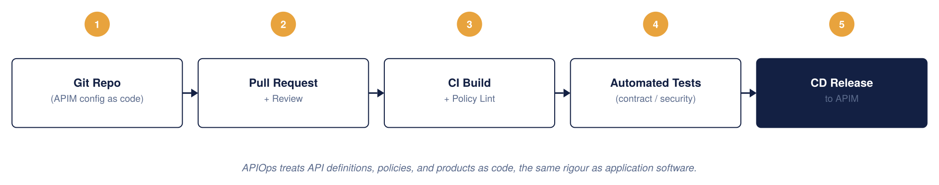
Figure 27: APIM CI/CD model, APIOps
APIOps tooling and pipeline (to be confirmed)
This design assumes an APIOps model but does not yet commit to specific tooling; that choice belongs to the Organization’s platform engineering standard rather than to this HLD, and should be confirmed and recorded as an architecture decision before build starts. The proposed default, consistent with a Microsoft-native Azure landing zone, is:
- Infrastructure as code: Bicep for the APIM instance, networking, Key Vault and Front Door resources, so the same templates promote unchanged through Dev, UAT and Production with only parameter files differing per environment.
- Configuration as code: the Azure API Management DevOps Resource Kit (APIOps) extractor/publisher tooling, or an equivalent, to represent APIs, products, policies and named values as files in Git rather than portal state.
- Source control and pipeline: a Git repository per the pattern already used elsewhere in the Organization’s Azure estate (Azure Repos or GitHub, run through Azure DevOps Pipelines or GitHub Actions), with mandatory pull-request review before merge to the branch that triggers Production deployment.
- Environment promotion: Dev builds on every merge to the integration branch; UAT and Production promote the same reviewed artefact through a manual approval gate, never a fresh build per environment, so what was tested is what ships.

APIOps and Deployment Approach
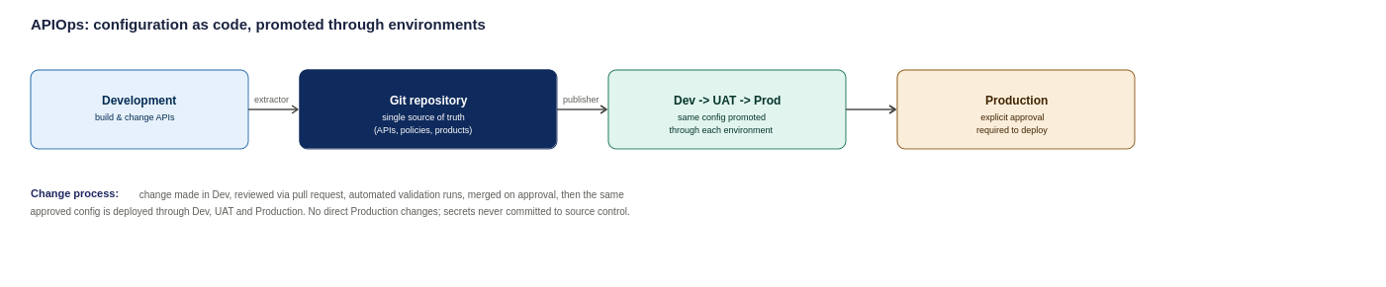
Figure 28: APIOps deployment pipeline, from development through to production
The proposed approach treats API Management configuration as code and stores it in a Git repository, which acts as the single source of truth. Changes are reviewed, approved, and deployed through automated pipelines rather than being made directly in Production.
Environment-specific settings
Some settings, such as backend URLs and timeouts, differ between environments. These are managed through environment-specific configuration files, while API definitions and policies remain the same across environments.
Security
- Secrets are stored securely and are not committed to source control.
- Pipeline identities follow least-privilege access principles.
- Production changes are made only through approved deployment pipelines.
- Direct Production access is restricted to authorised break-glass users.
Repository structure
The repository contains:
- APIs
- Policies
- Products
- Named values
- Backends
- Environment-specific configuration
- Deployment pipeline definitions

Configuration is promoted the same way through every environment; no environment is treated as a special case.
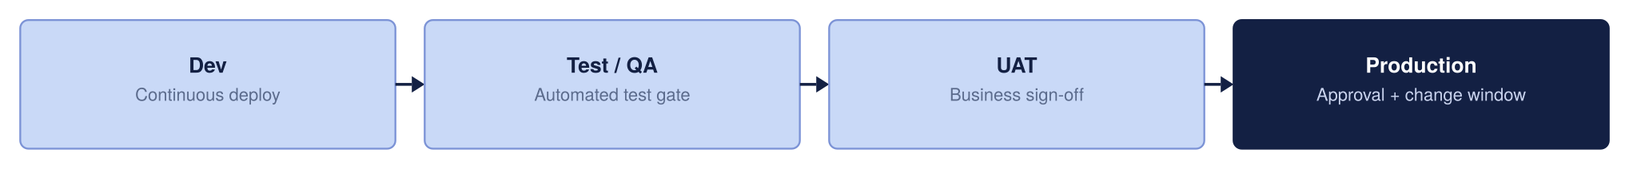
Figure 29: Environment promotion strategy

High Availability and Disaster Recovery Design
High availability is about surviving a failure inside one Azure region without anyone outside noticing. Azure Availability Zones are physically separate datacentres with independent power and cooling, when APIM is deployed across zones, the edge layer only sends traffic to zones that are healthy.
The diagram below shows the chosen high-availability design, zone-redundant APIM within a region behind Front Door. It supports the resilience decision in section 2 (zone redundancy as the default for every production API).
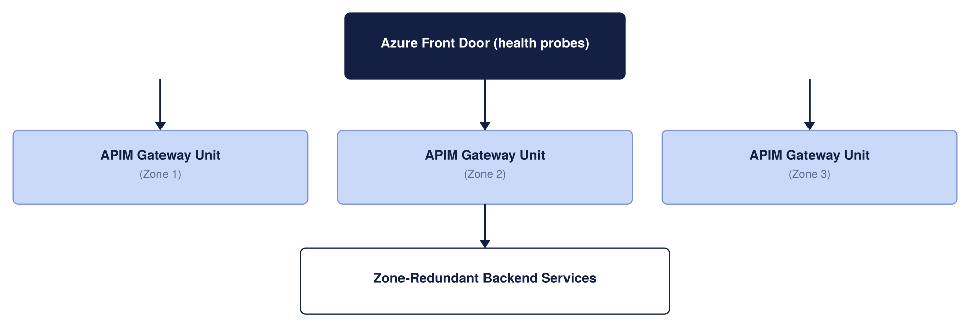
Figure 30: High availability architecture
Backend services should also be zone-redundant, a zone-resilient gateway in front of a single-zone backend only moves the weak point, it does not remove it. Zone redundancy carries no separate line-item cost on Premium or Standard v2, it is a configuration choice, not an add-on.
The whole chain is only as resilient as its weakest link
A highly available gateway does not make the transaction highly available on its own. The complete path, consumer to Front Door to WAF to APIM to the network to the backend integration services, is only as resilient as its least-resilient hop. Each component's resilience should be assessed and owned explicitly rather than assumed from APIM's own SLA.
Component | Resilience to confirm
Front Door + WAF | Global service confirm health-probe paths touch a real dependency, not a static page
APIM | Zone-redundant, multi-region for regional failure
Network (Firewall / NVA / DNS) | Confirm the egress and DNS path is itself resilient, not a single point of failure
integration services | Confirm the hosting plan is zone-redundant to match the gateway
Backend data stores | Each has its own replication and RPO; the worst one sets the real data RPO
Entra ID | Identity outage needs a break-glass path (section 8)

The single most important item to confirm here is whether integration services is configured for the same zone and regional resilience as the gateway, if it is not, the platform's real availability is set by the backend integration services, not by APIM.

Disaster recovery covers the rarer case: an entire Azure region becomes unavailable, not just one zone. For an insurance platform handling claims and policy data, this has to be planned for rather than hoped against.
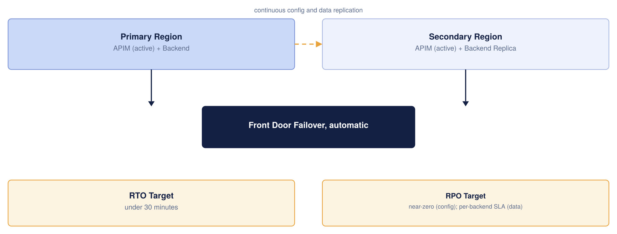
Figure 31: Disaster recovery architecture
Recommendation: Run APIM Premium active in both UK South and UK West behind the same Front Door entry point. Front Door already health-checks both regions, so a UK South failure moves traffic to UK West automatically. All configuration lives in Git through APIOps, so a region can be rebuilt from nothing if it ever has to be.
Metric | Target | What it means
Recovery Time Objective | Under 30 minutes, often seconds with active-active | How long the API layer is unavailable after a regional failure
Recovery Point Objective, configuration | Near zero | Configuration is rebuilt from Git, nothing is lost
Recovery Point Objective, data | Depends on each backend's own replication SLA | APIM does not create or remove this risk

Active-active roughly doubles the APIM unit cost, since a live Premium unit runs in each region. Active-passive saves less than expected, since standby units still bill close to full price. Given the sensitivity of claims and policy data, active-active is recommended for the most business-critical APIs, while lower-priority APIs use zone redundancy, so the higher run cost is paid only where it is justified (see the ranked options below).
Resilience is tiered by cost
The cost-tiered resilience options (single-region zone-redundant, active-passive, and active-active multi-region) and the recommendation to scope active-active only to business-critical APIs are set out in the Resilience Decision in section 2, and are not repeated here. This section covers how that choice is implemented: the zone-redundant and multi-region designs, RTO/RPO and the DR approach.
How this aligns with the chosen edge service (Front Door, Option A)
The HA/DR model here is not independent of the edge decision in section 2: it is a direct consequence of choosing Azure Front Door (Option A). Front Door is what makes multi-region active-active practical: it health-probes both regional APIM gateways, holds the single global hostname every consumer uses, and moves traffic from UK South to UK West automatically when a region’s probes fail, with no DNS-cache delay. Had the Organization chosen Option B (Application Gateway only), regional failover would not be built in and a separate global-routing layer would have to be added to achieve the same DR posture. The table makes the dependency explicit.
Resilience layer | Provided by (given Option A) | Effect
Regional failover | Front Door automatic origin failover (health-probed) | A UK South outage routes to UK West with no manual action or DNS wait
Single entry point | One Front Door global hostname for all consumers | Consumers are unaware of which region serves them; no client-side change on failover
Edge resilience | Front Door global anycast + edge WAF/DDoS | Volumetric and malicious traffic absorbed before it reaches either region
In-region HA | Zone-redundant APIM (classic Premium) behind Front Door | Survives loss of a single datacentre within a region
Backend resilience | Zone-redundant integration services, Functions and Service Bus | Confirmed separately: the chain is only as resilient as its weakest hop, confirmed per-backend with each backend team
Config recovery | APIOps / Git for both regions | A region can be rebuilt from code; RPO for configuration near zero

Global routing: Front Door or Traffic Manager
Front Door and Traffic Manager both do the same core job — steering traffic to a healthy region — but they work at different layers, and that difference is what drives the recommendation to use Front Door here.
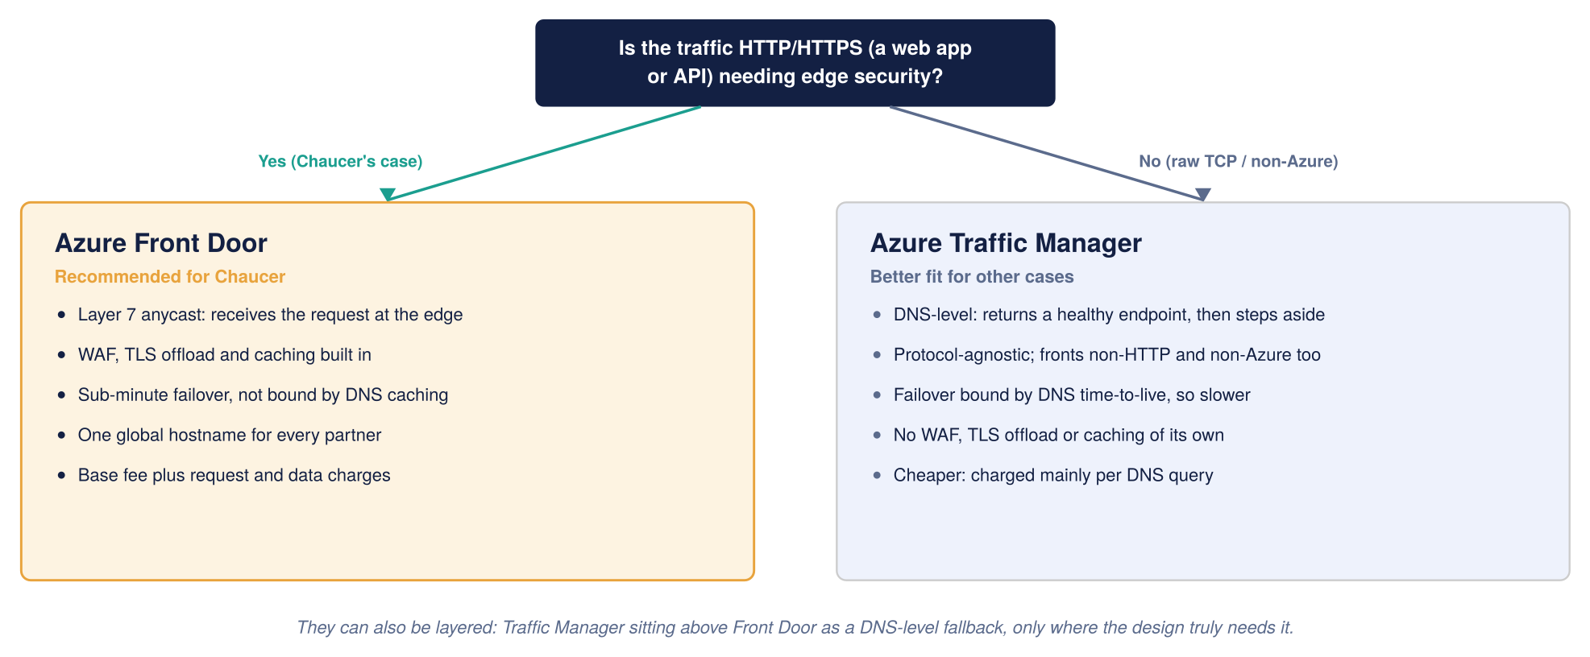
Figure 32: Global routing, Front Door compared with Traffic Manager

Consideration | Azure Front Door | Azure Traffic Manager
Routing layer | Layer 7, anycast, stays in the request path | DNS layer, returns an address then steps aside
Failover speed | Sub-minute, not bound by DNS caching | Bounded by DNS time-to-live, slower
Edge security | WAF, TLS offload, caching built in | None of its own
Non-HTTP and non-Azure endpoints | Not supported | Supported
Cost shape | Base fee plus request and data charges | Mainly per DNS query, cheaper
Fit for the Organization | Recommended, all traffic is HTTPS API traffic | Fallback only, or for future non-HTTP needs

On this basis the design standardises on Front Door as the global router and edge, with Application Gateway plus WAF retained only as the single-region fallback noted in section 2, and Traffic Manager noted as an option the Organization can layer in later if a non-HTTP or cross-cloud routing requirement emerges.

Capacity, Cost and Service Tiers
The figures below are indicative UK South list prices, gathered to give the Organization a realistic planning envelope. They are not a quote. Two things will move the real number: the Organization’s enterprise agreement with Microsoft usually discounts list price, and actual traffic volume drives the metered charges (requests, bandwidth, and log ingestion) that sit on top of the fixed platform cost.
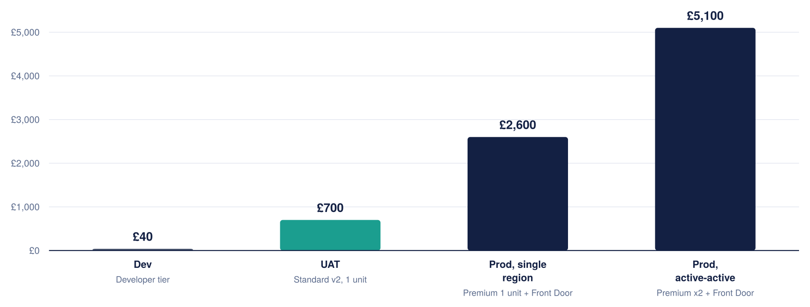
Figure 33: Indicative monthly platform cost by environment
Figures are indicative and must be confirmed against current Azure pricing: azure.microsoft.com/pricing/details/api-management
Cost per component, production
For a production environment the fixed monthly cost breaks down roughly as follows. A single Premium unit is the largest line by far, which is why the tier and single-versus-multi-region decision matters so much to the bill.
Component | Indicative monthly cost | Notes
APIM Premium, per unit | roughly £2,100 to £2,300 | The core gateway; active-active production runs two of these
Azure Front Door Premium + WAF | roughly £260 base, plus usage | WAF rules included in the base; requests and egress billed on top
Azure Key Vault | a few pounds per month | Priced per operation; negligible at this scale
Azure Monitor and Application Insights | usage-based | Driven by log volume; the main variable operational cost
Azure DDoS Protection (if on a dedicated plan) | roughly £2,300 per month per tenant | Shared across all workloads in the tenant, not APIM-specific

DDoS Protection is listed for completeness, but it is a tenant-wide service the Organization may already pay for; it should not be attributed to APIM alone. If the Organization has no dedicated DDoS plan, the infrastructure-level DDoS protection that comes free with Azure still applies.
How to keep the cost down
- Run Dev on the Developer tier, not Premium. It has the full policy engine and portal for a fraction of the price; its lack of an SLA does not matter for a build-and-test environment. UAT steps up to Standard v2 so business sign-off happens on an SLA-backed, production-like tier.
- Add Premium units only when capacity metrics require it. One unit covers a comfortable pilot; scaling out is a deliberate choice, not a default.
- Watch log ingestion. Application Insights and Log Analytics are usage-billed, so sampling verbose logs in production keeps the observability bill predictable.
- Confirm whether active-active is needed from day one, or whether a single-region start with active-passive DR is acceptable for the first phase, deferring the second Premium unit's cost until partner traffic justifies it.
Capacity planning and scaling
Cost and capacity both come down to how many scale units each environment runs. As a planning figure, a Premium unit handles roughly 1,000 requests per second, but this is not a hard limit: real throughput depends on payload size, connection patterns and policy cost, so it must be validated against the Organization’s own traffic.
Scale on the APIM capacity metric (gateway resource utilisation), not guesswork. Rules of thumb, to be tuned against real traffic: single-unit, add a unit above ~40% sustained; multi-unit, scale out above ~70% and in below ~35% on a 30-minute average. A scale operation takes ~30 minutes, so rules act on sustained trends; in multi-region, only the primary region autoscales (secondaries are sized manually).
Right-size each environment: Dev and UAT run minimal capacity; Production carries headroom for peak and for absorbing the other region’s share on failover. The starting model, to be confirmed against measured or forecast peak load:
Environment | Starting size | Indicative capacity | Sizing basis
Dev | Developer, 1 unit | Not applicable | Build and unit test only; no load target
UAT | Standard v2, 1 unit | ~1,000 req/s planning figure | Production-like sign-off; scale for test load, not prod peak
Production (per region) | Classic Premium, 1 unit to start | ~1,000 req/s per unit planning figure | Add units on the capacity metric; each region must hold peak load alone for active-active failover
Two capacity items to resolve during detailed design, flagged so they are not missed: the Organization’s expected and peak requests-per-second (which sets the real unit count and is not yet known to this design), and the active-active headroom rule: because either region must be able to carry the whole load during a failover, each region should be sized for peak on its own, not for half. Both feed the cost envelope in this section and are recorded in the assumptions register.

Operating Model

Service Handover

Risks, Assumptions and Decisions

High Level Impact Assessment
Introducing APIM adds a new, centrally-governed platform layer in front of the Organization’s existing integration estate. The impact is additive rather than disruptive: existing integration services continue to run, with APIM placed in front of them. The main new operational dependencies are the platform's networking (including the Palo Alto path), identity (Entra ID) and the APIOps pipeline. The subsections below summarise the impact by architecture domain.

Assumptions
This design is a well-formed proposal, not an Organization-verified fact base. The items below are assumptions or open decisions that carry real weight; several are stated as design choices elsewhere in this document for readability, but none should be treated as settled until confirmed. This register is the single place a reviewer, or the Organization’s TDA, should look to see where the design still depends on inputs we have not seen. It is deliberately blunt.
The Azure-capability assumptions below (tier features, network modes, multi-region support) can be validated against Microsoft’s authoritative documentation: the API Management feature-by-tier comparison (learn.microsoft.com/azure/api-management/api-management-features) and the reliability guidance (learn.microsoft.com/azure/reliability/reliability-api-management).
Ref | Assumption or open item | Impact if wrong | Owner to confirm
A.01 | This is a greenfield build; no legacy on-prem system needs direct APIM exposure | Introduces self-hosted gateway and hybrid connectivity, changing tier and topology | the Organization’s Enterprise Architecture team / Integration
A.02 | Backends already sit in a VNet reachable via Private Endpoint | The whole backend-connectivity design (section 6) may need rework | the Organization’s Network team
A.03 | the Organization’s landing zone follows a standard hub-spoke with private DNS zones available | Affects DNS, egress, and how APIM reaches each backend | the Organization’s Cloud Platform
A.04 | Entra ID is the Organization’s identity provider and can extend to API consumers | The entire authentication model shifts | the Organization’s Identity team
A.05 | UK South / UK West satisfy data-residency obligations | May force a different region pair or design | the Organization’s Compliance team
A.06 | Regulatory controls (FCA/PRA/Lloyd's/GDPR) can be met by the proposed design | Compliance is the least-verified area; controls need confirming | the Organization’s Compliance team
A.07 | The Traffic Manager reference in the SIF is shorthand for global routing, not a hard mandate | If mandated, the Front Door substitution needs explicit sign-off | the Organization’s Enterprise Architecture team / TDA
A.08 | Active-active multi-region is required from day one | If not, active-passive defers significant cost | The Organization + business
A.09 | Proposed RTO/RPO, retention periods, and alert thresholds are acceptable | Operational targets and cost may change | the Organization’s Operations team
A.10 | Traffic volumes fit one Premium unit for the pilot | Scaling changes the cost envelope | The Organization + Microsoft
A.11 | Tier price bands (Premium v2, classic Premium, and Standard v2) are current | Cost planning figures shift | Verify vs Azure pricing page
A.12 | Expected and peak API request rate (RPS) is not yet provided | Production unit count and autoscale thresholds cannot be finalised; capacity is a planning estimate only | the Organization’s Platform team + business
A.13 | Named accountable owners for each RACI role are not yet assigned | Governance and approval gates lack a specific owner; onboarding SLAs cannot be enforced | the Organization’s Platform team + Domain leads
A.14 | Log and correlation-ID retention period not yet confirmed with Compliance | PII/data-minimisation posture and evidence retention may not meet UK GDPR expectations | the Organization’s Compliance team + Security
A.15 | Subnet address ranges and IPAM allocation not yet validated | Subnet sizing (/26) and scale-unit headroom may not fit the landing zone | the Organization’s Network team
A.16 | Ownership and SLA for approving non-OAuth exceptions not yet assigned | Exceptions may persist without review; single-IdP posture weakened | the Organization’s Security team + API Platform

Risks
Ref | Risk | Likelihood | Impact | Mitigation
R.01 | Active-active multi-region materially increases run cost | Low | Medium | Confirm budget tolerance vs RTO before committing (A.08)
R.02 | Workspaces and multi-region require classic Premium a lower tier chosen for cost would block them | Low | Medium | Confirm tier before build (section 15)
R.03 | Palo Alto control-plane bypass mis-configured, breaking APIM connectivity | Medium | High | Follow the mandatory bypass route and gate in section 6
R.04 | Backend network topology differs from assumed, requiring rework | Medium | High | Validate landing zone early (A.02, A.03)

Issues
No live issues are recorded at draft stage. Issues raised during TDA review or build will be logged here.

Dependencies
Ref | Dependency | Owner
D.01 | Entra ID app registrations provisioned before build | the Organization’s Identity team
D.02 | Key Vault and access policy available in the target subscription | the Organization’s Platform team
D.03 | Landing-zone VNet, subnets and Palo Alto access for the firewall path | the Organization’s Network team
D.04 | Confirmed RTO/RPO, retention and alert thresholds | the Organization’s Operations team

Appendices

Microsoft Reference Architectures
Diagrams in this document are the Organization-adapted renderings of the pattern each article describes, not reproductions of Microsoft's own diagrams. Refer to the linked articles for Microsoft's original diagrams and downloadable Visio files.
- Basic enterprise integration on Azure: learn.microsoft.com/azure/architecture/reference-architectures/enterprise-integration/basic-enterprise-integration
- Protect APIs with Front Door and API Management: learn.microsoft.com/azure/architecture/web-apps/api-management/architectures/protect-apis
- Azure API Management landing zone accelerator: learn.microsoft.com/azure/cloud-adoption-framework/scenarios/app-platform/api-management/landing-zone-accelerator

Alignment with the Azure Well-Architected Framework
This design has been benchmarked against Microsoft's Well-Architected Framework (WAF) guidance for API Management, which sets out best practice across five pillars. The table below summarises each pillar, the key practices Microsoft recommends, and where this HLD addresses them. The alignment is high because the design was built to these patterns; the few items marked as configuration are settings to apply at build time rather than design gaps.
WAF pillar | Key Microsoft recommendations | How this design addresses it
Reliability | Zone redundancy; auto-scale; multi-region topology; isolate APIs with workspaces; test policies; collect reliability metrics; use backup and restore. | Classic Premium across Availability Zones (14); active-active UK South / UK West behind Front Door; workspaces per domain (9); APIOps config-as-code gives rebuild-from-Git (13).
Security | ARM control plane only; narrow TLS; certificates and secrets in Key Vault; backends accept traffic only from the gateway; OAuth 2.0; managed identity; WAF in front of internet-facing APIs; private connectivity; no tracing in production. | Entra ID and OAuth 2.0 with JWT validation (8); TLS 1.2 minimum; Key Vault-backed named values; backends private behind APIM; Front Door / App Gateway WAF; managed identity to backends; verbose tracing restricted to Dev (13).
Cost Optimization | Least-expensive tier that meets need; non-production on lower tiers; scale in on low demand; evaluate workspace cost model; use built-in cache; block malicious traffic before the gateway; optimise policy compute. | Developer tier for Dev, Standard v2 for UAT, Premium for Prod (13, 15); scale units only when metrics require; DDoS and WAF at the edge; indicative cost model with cost-reduction guidance (15).
Operational Excellence | Diagnostic resource logs; APIOps / GitOps; govern with Azure Policy; define operational metrics and logs; load testing; consistent API onboarding process; standardise hostnames; define backends via the backends feature. | Azure Monitor / Log Analytics / App Insights with correlation IDs (12); APIOps pipeline through Dev/UAT/Prod (13); repeatable API onboarding process (10.2); alert thresholds and audience dashboards (12).
Performance Efficiency | Dynamically scale to demand; minimise expensive policy processing; collect performance metrics; set an Application Insights sampling percentage; evaluate logic placement; review service limits. | Auto-scale on capacity metrics (15); reusable, lean policy library (10.2); p95 latency and capacity alerting (12); App Insights sampling in production to control cost and overhead (12).
Based on Microsoft’s Azure Well-Architected Framework guidance for API Management: learn.microsoft.com/azure/well-architected/service-guides/api-management
Source: Microsoft Azure Well-Architected Framework, Architecture best practices for Azure API Management. The full checklist and per-recommendation detail are maintained by Microsoft at learn.microsoft.com and are summarised, not reproduced, here.

Glossary and Definitions
The terms below are used throughout this document.
Term | Meaning
APIM | Azure API Management, the managed API gateway service
WAF | Web Application Firewall
Entra ID | Microsoft Entra ID, the identity provider (formerly Azure AD)
UDR | User-Defined Route, a custom route-table entry
NVA | Network Virtual Appliance, here the Palo Alto firewall
APIOps | Managing APIM configuration as code through a CI/CD pipeline
RTO / RPO | Recovery Time / Point Objective
mTLS | Mutual TLS
FNOL | First Notification of Loss, the initial report of an insurance claim
SIF | Systems Integration Framework, the client’s integration reference document
RACI | Responsible, Accountable, Consulted, Informed, a responsibility model
BOLA | Broken Object-Level Authorization, an OWASP API risk
SoD | Segregation of Duties
HLSA | High-Level Solution Architecture
DNAT / SNAT | Destination / Source Network Address Translation
IPAM | IP Address Management
SIEM | Security Information and Event Management
DPIA | Data Protection Impact Assessment
FCA | Financial Conduct Authority, a UK regulator
PRA | Prudential Regulation Authority, a UK regulator
UK GDPR | UK General Data Protection Regulation
JWT | JSON Web Token
DDoS | Distributed Denial of Service
SLA | Service-Level Agreement
VNet | Azure Virtual Network
Private Link | Private connectivity to an Azure service over the Microsoft backbone

Sample Policy Fragments, Naming and OpenAPI Skeleton
Illustrative artefacts to make the standards concrete for build teams. These are examples to adapt, not final Organization policy.
JWT validation (inbound), Entra ID:
<validate-jwt header-name="Authorization" failed-validation-httpcode="401"
failed-validation-error-message="Unauthorized">
<openid-config url="https://login.microsoftonline.com/{tenant}/v2.0/.well-known/openid-configuration" />
<required-claims>
<claim name="aud"><value>api://organization-apim</value></claim>
</required-claims>
</validate-jwt>
Rate limiting and quota, per subscription:
<rate-limit-by-key calls="100" renewal-period="60"
counter-key="@(context.Subscription.Id)" />
<quota-by-key calls="100000" renewal-period="86400"
counter-key="@(context.Subscription.Id)" />
Sunset header during a deprecation window (RFC 8594):
<set-header name="Sunset" exists-action="override">
<value>Sat, 30 Nov 2026 23:59:59 GMT</value>
</set-header>
<set-header name="Deprecation" exists-action="override"><value>true</value></set-header>
Backend authentication using a managed identity (no secret in policy):
<authentication-managed-identity resource="api://organization-backend" />
Resource and API naming examples:
Resource group : rg-apim-prod-uksouth
APIM instance : apim-organization-prod-uksouth
API path : /api/claims/v2/claims
Named value : nv-claims-backend-baseurl
Product : prod-external-broker
Entra group : grp-apim-external-broker
OpenAPI skeleton (the contract every API starts from):
openapi: 3.0.3
info:
title: Claims API
version: "2.0.0"
servers:
- url: https://api.organization.example/api/claims/v2
paths:
/claims/{id}:
get:
summary: Retrieve a claim
security:
- oauth2: [claims.read]
parameters:
- name: id
in: path
required: true
schema: { type: string }
responses:
"200": { description: OK }
"401": { description: Unauthorized }
"429": { description: Too Many Requests }

Threat model: STRIDE and OWASP in detail
This appendix holds the full framework-by-framework threat mapping summarised in section 8 (Authentication and Security Design). It is written for the security architect reviewing the design against recognised threat models. The one-page summary in section 8 is the quick reference; this is the complete mapping behind it.
The design has so far been described control by control; this maps those controls to two recognised frameworks so gaps are visible. The STRIDE view covers platform-level threat categories; the OWASP API Security Top 10 (2023) view covers the API-specific risks Compliance and Security will expect to see addressed. Where a risk can only be closed at the backend, that is stated plainly rather than implied to be handled at the gateway.

STRIDE: platform-level threats
Threat category | Example | How this design addresses it
Spoofing | A caller impersonates a legitimate consumer | Entra ID OAuth 2.0 + JWT validation at the gateway; single IdP; mTLS/certificate for approved exceptions
Tampering | Request or response altered in transit | TLS 1.2+ end-to-end; Front Door WAF; request schema validation
Repudiation | A caller denies an action they performed | Correlation IDs on every request; per-consumer logging to Log Analytics/SIEM; immutable audit trail
Information disclosure | Sensitive data leaks to an unauthorised party | Least-privilege products/scopes; payload logging off by default with redaction; Private Endpoints; no secrets in policy
Denial of service | The platform is overwhelmed | Front Door DDoS + WAF; per-subscription rate limits and quotas; capacity-based autoscale
Elevation of privilege | A caller gains access beyond their grant | Product/group-scoped access and scopes; backend function/object-level checks; RBAC on the control plane; logged break-glass
The OWASP API Security Top 10 (2023) below covers API-specific risks, the ones a platform-level threat model alone would miss:

OWASP API Security Top 10 (2023)
Risk | How this design mitigates it | Primary owner
API1 Broken Object Level Authorization | Backend must authorize each object; APIM forwards validated identity/claims but cannot authorize objects itself | Domain teams
API2 Broken Authentication | Entra ID OAuth 2.0; JWT signature/issuer/audience/expiry validated at the gateway; no anonymous production APIs | Platform + Identity
API3 Broken Object Property Level Authorization | Response field filtering/schema validation in policy where applicable; backend enforces property-level access | Domain teams
API4 Unrestricted Resource Consumption | Per-subscription rate limit and quota; payload size limits; timeouts; autoscale | Platform
API5 Broken Function Level Authorization | Product/group scoping and JWT scopes; backend enforces function-level authorization | Platform + Domain
API6 Unrestricted Access to Sensitive Business Flows | Tighter per-flow rate/quota and Front Door bot protection on sensitive flows | Platform + Domain
API7 Server-Side Request Forgery | Backend URLs are allow-listed, never user-controlled; egress inspected by the firewall | Domain + Network
API8 Security Misconfiguration | Everything-as-code (APIOps); baseline policies; WAF managed rules; no portal edits in Production | Platform
API9 Improper Inventory Management | Central catalogue and developer portal; lifecycle/audience tagging; versioning + deprecation; single ingress prevents shadow APIs | Platform
API10 Unsafe Consumption of APIs | Validate, schema-check and time-limit calls to third-party APIs; TLS; circuit-breaking | Domain teams

APIM End-to-end build and API onboarding flow
This appendix brings the whole document together in one picture. Now that the foundational components, network modes, and security model have been described in the sections above, the swimlane below shows the complete journey, which team owns each stage, where responsibility hands over, where the approval gates sit, and which section of this document each team should read. It is placed here deliberately, as a final synthesis, so it can be read with the detail of the preceding sections already in mind.
Purpose of the diagram below: to show the whole journey from a business need to a live platform ready for APIs, and exactly which team owns each stage. What to look at: read it left to right as seven phases across the top, and top to bottom to see which team (each row) is active in each phase; the arrows are the handovers, and the red dots are the two points where the Technical Design Authority must approve before work continues. Key takeaway: this is a sequenced, multi-team effort with clear ownership and two hard approval gates, not a single team’s task, and it does not end at go-live, API onboarding is an ongoing activity the platform is built to support. Each box also names the section of this document that team should read for the detail behind its activity.
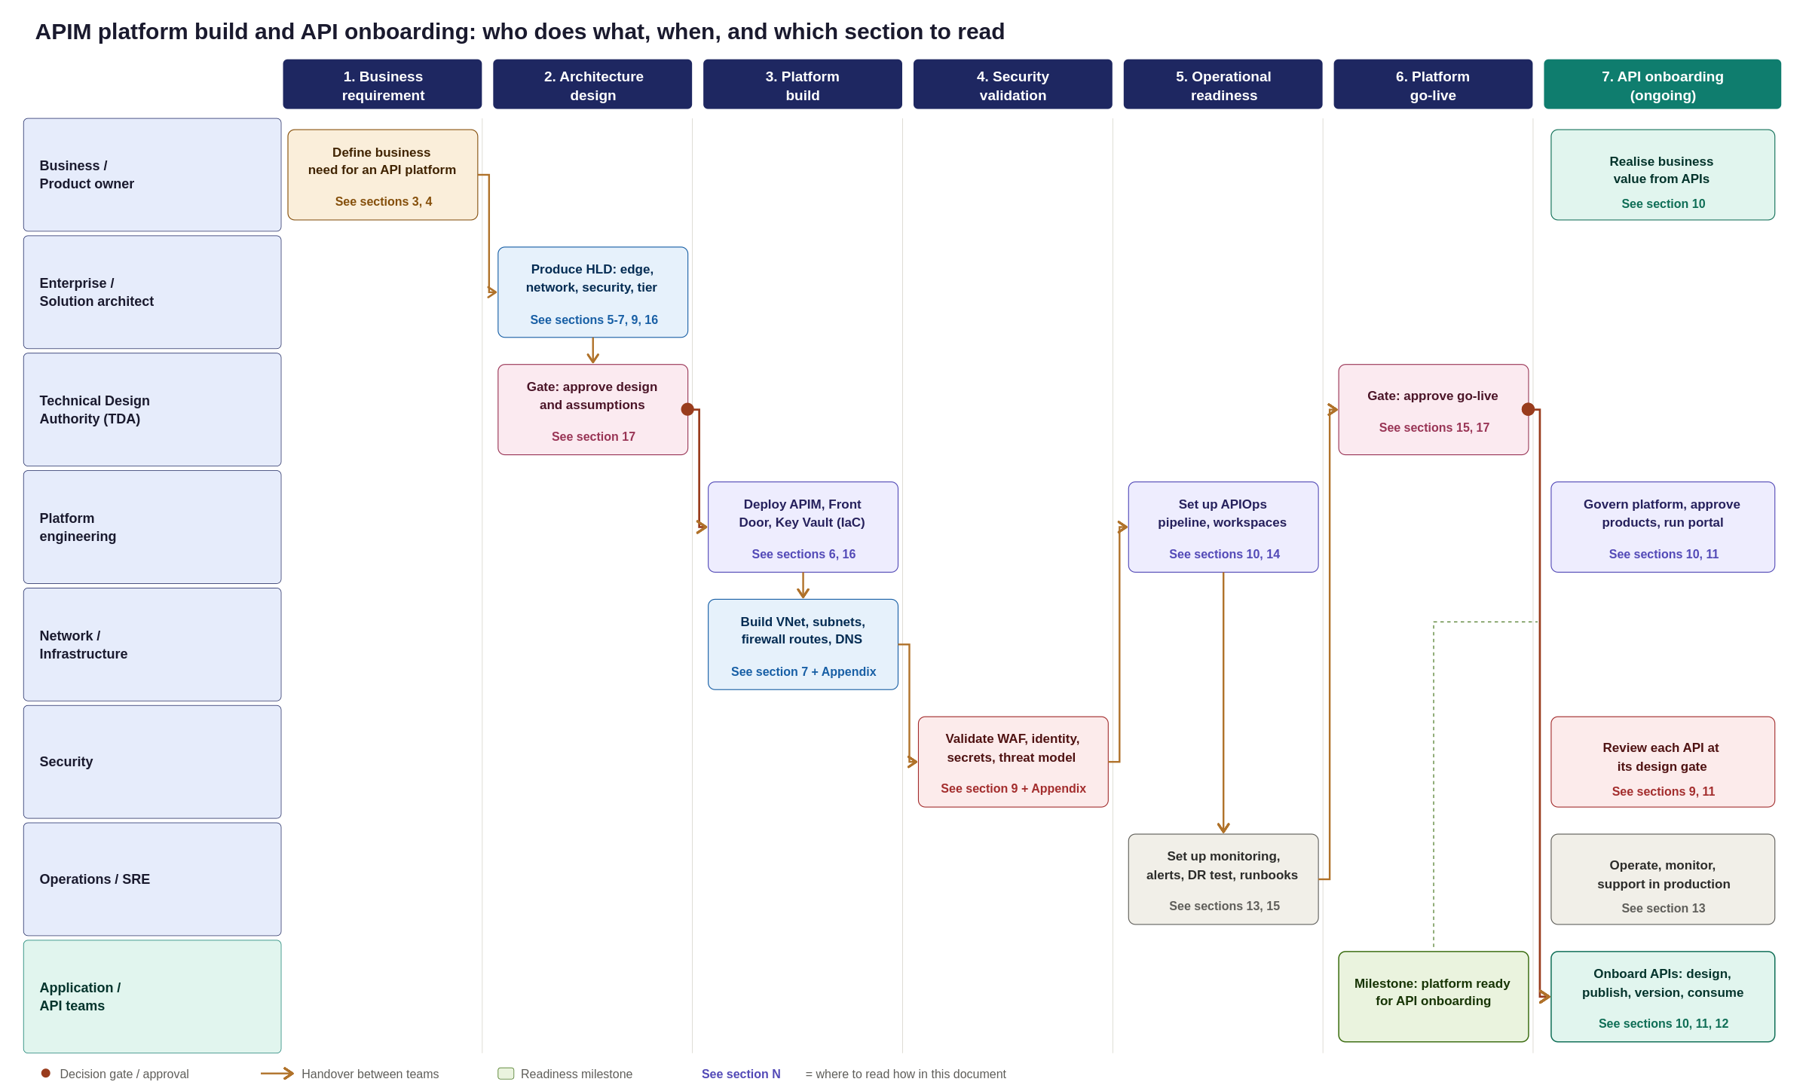
Figure 34: APIM platform build and API onboarding swimlane, from business requirement to production consumption
What this means for planning: standing the platform up is a cross-team programme with a clear critical path, architecture and TDA sign-off first, then a parallel platform-and-network build, then security validation and operational readiness, then a final go-live gate. Only after that milestone do application teams begin onboarding APIs, which then runs continuously. The sections that follow detail what each phase involves.

